Assignment 1 Stage 2

Personal Moodle Profile: Leigh Scherer
Personal Blog Link: https://leighsfreshst.art.blog/

Assignment 1 Stage 3

My Company - ScanTech

https://www.scantech.com.au/
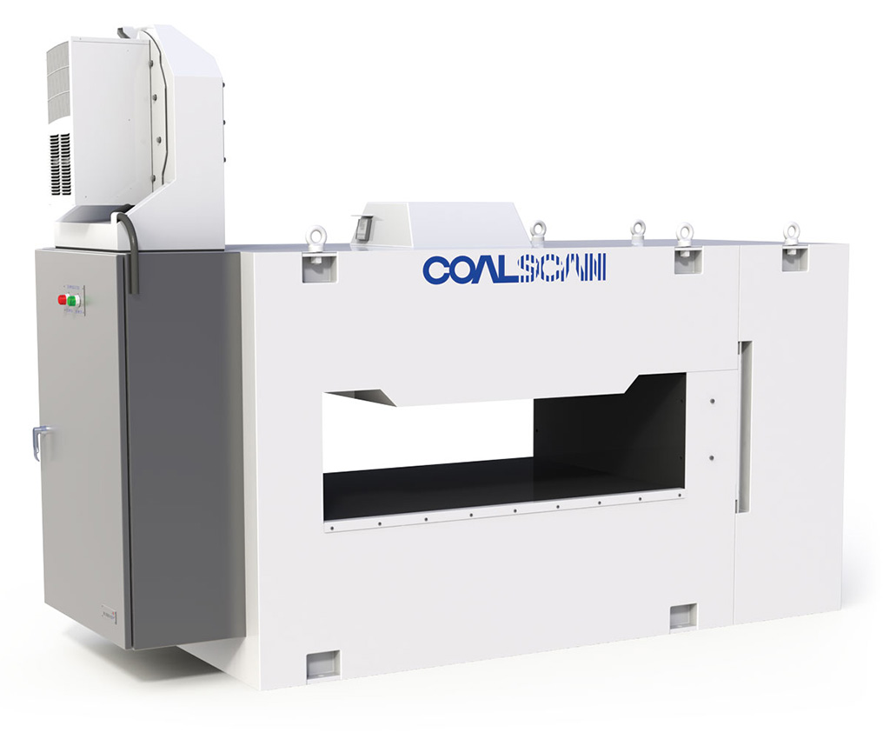

I would like to introduce you to my company ScanTech. As illustrated on my blog https://leighsfreshst.art.blog/ my company creates modern online analyzers for bulk materials.
The Company has developed a broad range of industrial instrumentation utilising various measurement technologies, including microwave methods. It deals mainly in the resource sector including cement, coal and mineral industries. The COALSCAN 1500 is an on-line ash monitoring system which is installed under production conveyor belts.

Initially I was excited to receive this company as I read it was used in the cement, coal and mineral industries and thought I could relate this company to the company I have worked for the last ten years as it is the same field. However, as I went through the financial background and highlights my thoughts turn a little to confusion as I couldn’t relate the same financial background to the financials I have dealt with over time. I needed to read on and find out why.

Annual report 2018 – ScanTech
http://shareholders.scantech.com.au/shareholder/?page=reports-publications

The first page of the annual report includes a financial highlights breakdown for 2015 to 2018. I noticed from the outset that the strategy that was adopted in the last year of 2018 had brought a huge financial gain to the company and its shareholders. Revenue increased for 2015 by 13%, dipped in 2017 and then had a 21% growth for 2018. My first curiosity was, what happened in 2018 to bring such growth in revenue? This also sparked the 646% increase in profit after tax in 2018 after only achieving a 7% profit after tax in 2017. Their numbers struck me as a bid odd and wondered how could a company manage such influx in numbers. The vast escalation in reporting numbers is much different to the industry I am used it. The maintenance, shutdown and utilities labour services which I have been a part of for the past 10 years certainly doesn’t show such increases in profit after tax and always sat around a 4% EBIT. I really enjoyed entering the company financials records into the spread sheet for the last four years and even more excited I could work out the formulas as recently learned in Chapter 1.
Assets = Equity + Liabilities
I have included my spread sheet below and you can see I played around with the 5 principles of accounting.

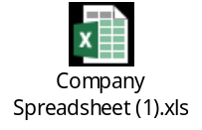

The financial statements were not too in-depth and easy to link the profit to the equity movements. As mentioned in my blog I worked out the % profit made in the 2015-2018 years. 2015 to 2017 the GM % return was only 1% in profit however 2018 brought a 7% GM return. The financial assets of the company increased by $3m in 2018 which I think contributed to the huge growth in 2018. Dispute having such a high growth in 2018 the report didn’t go into detail of any success strategies used and I was a little disappointed not to learn what factors could have influenced this.

I was intrigued to read through the board of members and their accounting qualifications and noticed the lengthy service of its members. The longest serving one was appointed in 2001 and the others ranged between 2003 and 2005. The company secretary has been with ScanTech for 17 years. Having such long-appointed board members would instill confidence and trust within the business and its customers and clients and also contribute to a higher growing economy.

I’m trying to visualize the services and equipment it would sell to its customers. The annual report states that ScanTech design, manufacture and service of real time measurement technologies for conveyed bulk materials. In my words I see that the company sells equipment that measures bulk materials in the coal and cement industries. Scantech has supplied over 1,100 analysers to customers in 55 countries.
Their vision and growth from starting out in 1981 (a year after I was born) to now has certainly been rewarding. The company has received many awards in this time. I have listed one of the top awards below from the annual report:

Dr Jim Howarth along with other scientists won the prestigious Australia Prize in 1992. This award formally recognised the excellence of the COALSCAN range of analysers. The Prime Minister presented the award for scientific achievement to Dr Jim Howarth and colleagues for developing and commercialising instruments for the on-line analysis of minerals and coal.

Also, from the website below:
CSIROpedia - https://csiropedia.csiro.au/international-awards/#InternationalAwards-AustraliaPrize
The Australia Prize was Australia’s pre-eminent prize for scientific research from 1990 until 2000, when it was replaced by the Prime Minister’s Prize for Science. The award was international, 10 of the 28 recipients were not Australians.
Perusing the actual equipment listings from a GEOSCAN to a COALSCAN 2100 I am still trying to visualise these big rigs in action. The equipment description of each one is quite impressive and I am going to go hunting for a picture of one in action. I have sourced the below:
By E brien - Own work, Public Domain, https://commons.wikimedia.org/w/index.php?curid=7729866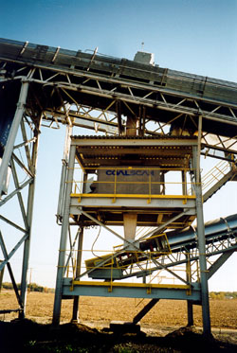
I’m surprised also by the environmental benefits of these equipment. They can reduce greenhouse gas emissions, sulphur emissions, acid rain and waste. The report goes into detail regarding the coal, cement and minerals services and I now have a clearer picture of how the equipment blends these products to produce a more consistent, higher quality material.

It was interesting to read through the financial basis of accounting that ScanTech estimates in the financials reports. They use historical knowledge and best available current information to assess future developments. At the end of each quarter management assess the percentage completion of all current jobs and revenue is recognized based on the stage of completion. Any expected loss on construction contracts are recognized as an expense immediately in profit or loss. It makes me wonder what accounting systems they are using for this as I compare to the current system I use (SAP) whereas revenue is recognized in relation to costs not stage of completion. The annual report goes into details regarding the accounting standards used and the AASB reference. By this point in time I was starting to panic and feel a little daunted by the interpretation of these standards. It only listed 8 but these ones were complex and I can just begin to imagine how many accounting standards and rules exist. I know this topic is introductory accounting but having a glimpse into the real world of accounting and its applications is somewhat surreal.

By Leigh Scherer
CQU University - ACCT11059 ACCOUNTING, LEARNING & ONLINE COMMUNICATION

I have concluded the assignment with the below

https://www.scantech.com.au/wp-content/uploads/2015/05/world_coal_sept_09__cs1500.pdf

This machine is currently being used in Mt Owen Coal operations in Singleton, Hunter Valley NSW. The mine is a truck and excavator operation producing coals mostly destined for export through the Port of Newcastle. Raw coal quality is maintained by Coalscan 1500online ash analysers, and the product quality is controlled by a Coalscan 3500 analyser.

“The Coalscan 1500Natural Gamma Ash Monitor determines the ash content of coal on a moving conveyor belt by measuring the level of naturally occurring radioactive elements in the coal ash. The system consists of a large scintillation detector that is mounted in a lead lined enclosure, which is bolted longitudinally between the stringers underneath the conveyor belt.

The natural gamma rays are detected, amplified and transmitted to a digital multi-channel analyser (DMCA), which processes the counts and passes the data to the onboard computer. The computer then calculates the ash value.

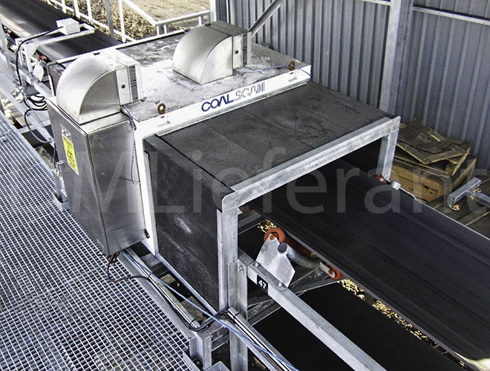
My three Top Blogs and reasons why –

Comparisons of other firms.

Give feedback for three other firms.

