

Ass# 1 Step 2
Personal Moodle Profile: Leigh Scherer
Personal Blog Link: https://leighsfreshst.art.blog/

Ass# 1 Step 3
My Company - ScanTech
https://www.scantech.com.au/
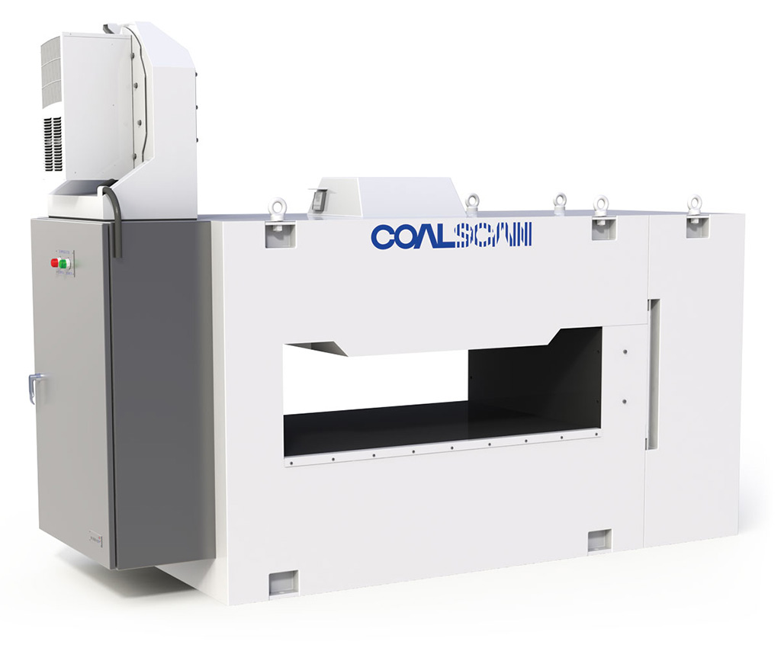

I would like to introduce my company ScanTech. My company creates modern online analysers for bulk materials. The Company has developed a broad range of industrial instrumentation utilising various measurement technologies. I was very excited to receive this company as it deals mainly in the resource sector, which is similar to my field of work. My initial question was what could I compare from my work experiences to this company? What story can I tell based from the financial history of this company with the financial highlights? As I went through the financial highlights and examined my company, I tried to decipher their last four years of financial statements and accounting history and piece together the business realities of this new company.
ScanTech History …
https://www.scantech.com.au/history/
Scantech has supplied over 1,100 analysers to customers in 55 countries.
Founded in 1981 by Dr Jim Howarth and Richard Kelly, Scantech has grown from a small private company based in Adelaide, South Australia to a successful public enterprise. During this time, they have won multiple awards as listed below:
- Dr Jim Howarth along with other scientists won the prestigious Australia Prize in 1992. This award formally recognised the excellence of the COALSCAN range of analysers. The Prime Minister presented the award for scientific achievement to Dr Jim Howarth and colleagues for developing and commercialising instruments for the on-line analysis of minerals and coal.
- The Research and Development Magazine IR 100 Award for the On-Line Ash Measurement System.
- The Sir Ian McLennan Achievement for Industry Award won jointly with another research organisation to recognise the commercial development of the COALSCAN 4500.
- The Electronics Association of South Australian Gold Cup for excellence in commercialisation and engineering of the COALSCAN 9500 On-Line Elemental Analyser.
- The Powerhouse Museum in Sydney has recognised Scantech’s COALSCAN as one of the most significant Australian innovations of the 20th century.
As I peruse the board of members and their qualifications, I noticed the lengthy service of its members. The longest serving member was appointed in 2001 and the others ranged between 2003 and 2005. The company secretary has been with ScanTech for 17 years. What merits did this company uphold to have such long serving members? Would this contribute to a successful company?

As I read through the history of this company, I came across the shareholders information tab. I found it quite surprising that Scantech is an unlisted public company and disclosing entity. Scantech’s shares are not listed on any licensed market or exchange, including the Australian Securities Exchange. In order to provide shareholders with some liquidity for their shares, Scantech has received approval from the Australian Securities and Investments Commission (ASIC) to operate a low volume financial market. How could a company delist from the stock exchange and still manage the sale of shares? I did some further research to the process. The link below shows how to apply for shares for ScanTech and also details pf the buy back scheme. This is where I started seeing the similarities of the Annual report 2018 and the financial highlights.
http://shareholders.scantech.com.au/shareholder/?page=how-to-buy-or-sell-shares


Equipment

As I delved through the website of my company, I wanted to visualise one of these pieces of equipment in action. How do they analyze raw products? Where in Australia were, they situated?
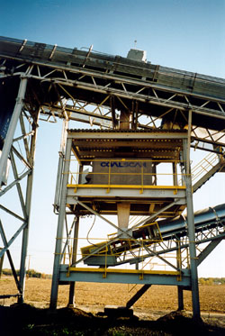
By E Brien - Own work, Public Domain, https://commons.wikimedia.org/w/index.php?curid=7729866

https://www.scantech.com.au/wp-content/uploads/2015/05/world_coal_sept_09__cs1500.pdf
I found the COALSCAN 1500 being used in Mt Owen Coal operations in Singleton, Hunter Valley NSW. The mine is a truck and excavator operation producing coals mostly destined for export through the Port of Newcastle. Raw coal quality is maintained by Coalscan 1500 online ash analysers, and the product quality is controlled by a Coalscan 3500 analyser.

“The Coalscan 1500Natural Gamma Ash Monitor determines the ash content of coal on a moving conveyor belt by measuring the level of naturally occurring radioactive elements in the coal ash. The system consists of a large scintillation detector that is mounted in a lead lined enclosure, which is bolted longitudinally between the stringers underneath the conveyor belt”

The natural gamma rays are detected, amplified and transmitted to a digital multi-channel analyser (DMCA), which processes the counts and passes the data to the onboard computer. The computer then calculates the ash value.

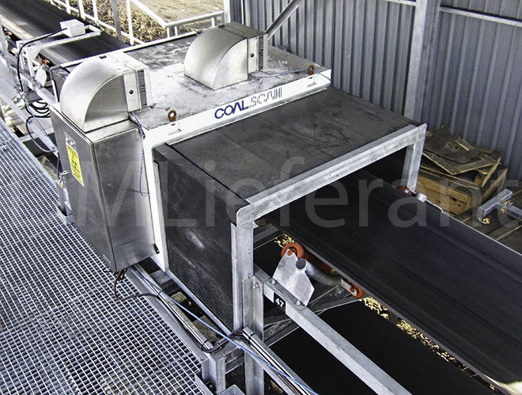

Environmental benefits of this equipment include reducing greenhouse gas emissions, Sulphur emissions, acid rain and waste.

Annual report 2018 – ScanTech
http://shareholders.scantech.com.au/shareholder/?page=reports-publications

The first page of the annual report includes a financial highlights breakdown for 2015 to 2018. I noticed from the outset that the strategy that was adopted in the last year of 2018 had brought a huge financial gain to the company and its shareholders. Revenue increased for 2015 by thirteen percent, dipped in 2017 and then had a twenty-one-percentage growth for 2018. My first curiosity was, what happened in 2018 to bring such growth in revenue? This also sparked the six hundred- and forty-six percent increase in profit after tax in 2018 after only achieving a seven percent profit after tax in 2017. Their numbers struck me as a bit odd and I wondered how could a company manage such influx in numbers. The vast escalation in reporting numbers is much different to the industry I am used it.
It was interesting to read through the financial basis of accounting that ScanTech estimates in the financials reports. They use historical knowledge and best available current information to assess future developments. At the end of each quarter management assess the percentage completion of all current jobs and revenue is recognized based on the stage of completion. Any expected loss on construction contracts are recognized as an expense immediately in profit or loss. What accounting systems they are using for this revenue recognition? What is the process if the project is dismantled and revenue is too high? The annual report goes into details regarding the accounting standards used and the AASB reference. By this point in time I was starting to panic and feel a little daunted by the interpretation of these standards. It only listed 8 but these ones were complex and I can just begin to imagine how many accounting standards and rules exist. I know this topic is introductory accounting but having a glimpse into the real world of accounting and its applications is somewhat surreal.
Studiosity
What a great service! I thought my initial draft of my assignment wasn’t too bad but after reading the feedback from Studiosity and applying their feedback I am more confident in my second draft. The feedback was precise and to the point and the paragraphs were highlighted which required more attention. We certainly didn’t have this technology or level of expertise readily available twenty years ago!! Below is some of the feedback I received:
“Try to end your analysis appropriately with a sense of closure and emphasis on the main idea/ideas that were discussed”
“I suggest that you close with a strong closing statement. I have highlighted this part at the end for you to revise.”
“Never assume that your readers know all the abbreviated meanings”
I can certainly say I feel way more confident in writing my assignment and reflecting the structures of a more thorough presentation.

Ass# 1 Step 4
I really enjoyed entering the company financials records into the spread sheet for the last four years and even more excited I could work out the formulas as recently learned in Chapter 1.
Assets = Equity + Liabilities
I have included my spreadsheet below.

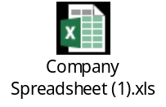

As mentioned in my blog I worked out the percentage profit made in the 2015-2018 years. 2015 to 2017 the gross margin percentage return was only one percent in profit however 2018 brought a seven percent gross margin return. The financial assets of the company increased by $3 million in 2018 which I think contributed to the huge growth in 2018. Dispute having such a high growth in 2018 the report didn’t go into detail of any success strategies used and I was a little disappointed not to learn what factors could have influenced this.
Conclusion

I have compared my company to many blogs posted on Facebook and blog forums and found my company certainly not on the scale as others in terms of volume of numbers. All companies are different in financial strengths and weakness. Some companies provide much more detail in strategy’s highlights and downfalls. However, I must admit I’m a little happy to receive a company that was making a profit. I would much rather see the word profit than the word LOSS. The story I can tell from the financial background of this company is one of success and progress. Emerging from a financial downturn in 2014 with the first reported loss to a one million profit in 2018 is a success story I would love to talk about.

By Leigh Scherer
CQU University - ACCT11059 ACCOUNTING, LEARNING & ONLINE COMMUNICATION

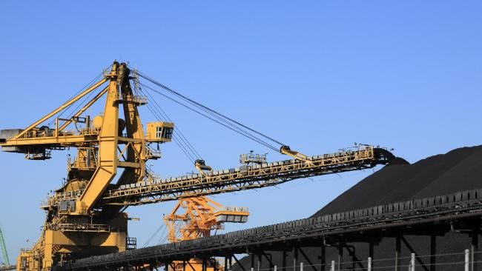

Ass# 1 Step 5
Chapter 2 – Understanding the Game

I recently completed an excel course the other day and the teacher was an accountant. Penny (the teacher) started to tell me about her accounting career and what she said was quite ironic. Penny first worked in management accounting and she said her job was to basically ask the managers what numbers they wanted to see and produced it. Penny then moved into financial accounting and this involved reporting on the actual numbers. Penny said that job was boring compared to the first job and I found that quite hilarious. Is it really about understanding the game or about how people want to see the numbers?

I find the concept “Is Accounting a game where we can manipulate and move around accounting numbers or is accounting something else”. Based from Penny’s conversation above I think there are two very distinct requirements of accounting. One is the management accounting which I am very accustomed to. If I may relate this to my personal experience, I have had two very different accountant managers. One was very rule driven and followed every accounting practice. The other not so rule driven and very willing to “manipulate the numbers” to suit. The other is financial accounting. I haven’t had much experience in this field however from reading through the annual reports of my company and other companies I can see there are principles and accounting standards that have been followed.
We recently had two major companies in our region go into liquidation. Both surprising as the market for the services they provided were quite solid. As I read through “why is a firm’s financial statements important to employees, customers, banks, shareholders” I begin to wonder if the people who had stakes into these two companies read the financial statements provided. Did these people gain an insight into the business realities of this company and could predict the downfall? Did the financial statements show the impending downfall? One of these companies weren’t able to pay their employees the leave benefits owed to them. Was this depicted in the financial statements? Reading through the annual report of my company I certainly don’t have the experience or knowledge to understand each accounting term however it has given me an appreciation that there are rules that need to be followed.

GAAP – GAAP is the rules the need to be followed.
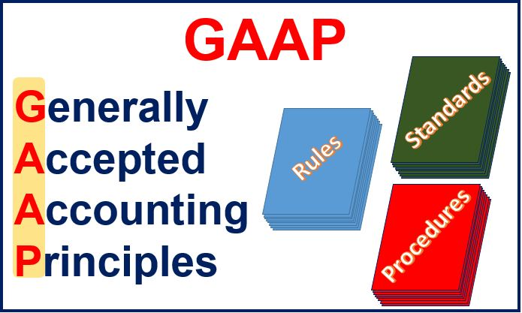
What is GAAP? Generally accepted accounting principles that accountants need to follow when preparing financial statements. An interesting concept that I wanted to learn more about. What were the main GAAP principles? I did a little research:
https://www.investopedia.com/terms/g/gaap.asp

These 10 general principles can help you remember the main mission and direction of the GAAP system.
1.) Principle of Regularity -The accountant has adhered to GAAP rules and regulations as a standard.
2.) Principle of Consistency -Professionals commit to applying the same standards throughout the reporting process to prevent errors or discrepancies. Accountants are expected to fully disclose and explain the reasons behind any changed or updated standards.
3.) Principle of Sincerity -The accountant strives to provide an accurate depiction of a company’s financial situation.
4.) Principle of Permanence of Methods -The procedures used in financial reporting should be consistent.
5.) Principle of Non-Compensation -Both negatives and positives should be fully reported with transparency and without the expectation of debt compensation.
6.) Principle of Prudence- Emphasizing fact-based financial data representation that is not clouded by speculation.
7.) Principle of Continuity - While valuing assets, it should be assumed the business will continue to operate.
8.) Principle of Periodicity -Entries should be distributed across the appropriate periods of time. For example, revenue should be divided by its relevant periods.
9.) Principle of Materiality / Good Faith -Accountants must strive for full disclosure in financial reports.
10.) Principle of Utmost Good Faith -Derived from the Latin phrase “uberrimae fidei” used within the insurance industry. It presupposes that parties remain honest in transactions.
To me it sounds like a secret accountant’s group where thou shalt not break any of the above rules. Reading the above fundamentals gives me an appreciation of how important it is for accountants to represent the companies they provide a service for and the laws by which they abide to provide the most correct and up to date financial information that they can.

REAL Learning
Companies which are considered sole traders, partnerships, trusts and government entities must issue general purpose financial statements and need to comply with all these accounting rules. During my day job I was recently asked to assess the financial statements of one of our subcontractors and attend some meetings to discuss their financial performance. It was a cleaning company working for one of our maintenance contracts. I was a little nervous at the prospect as I hadn’t viewed many financial statements before. As I looked over the financial statements, I could recognize the ledger accounts through the profit and loss and balance sheet. I could also see the trend of the company recovering from a few financial problems. It was during these meetings where I learned that certain information had to be displayed and reported on. For example, a tax debt and overdue superannuation contributions. Chapter 2.2 talks about real learning. Connecting what we are learning with our prior knowledge and previous experience as we seek to make sense of things which are new to us. Above is a great example of this. I have also found reading through other people blogs how they interpret and analyse their own companies and ask questions helps me learn the fundamentals of the accounting game.

Accrual Accounting
I relate this back to thou shalt not pass rule #8
8.) Principle of Periodicity -Entries should be distributed across the appropriate periods of time. For example, revenue should be divided by its relevant periods.
I have had many experiences with accrual accounting and one in particular was between the two managers (one rule driven and one not so rule driven). The rule driven manager was opposed to taking any accruals for transactions which had not occurred as yet. Whereas the other manager was a little more relaxed and if it was a potential opportunity then an accrual could be taken. What are the risks associated with this? If the potential opportunity did not eventuate would this be considered over stating the revenue? My manager was telling me the other day that this has happened in other parts of the company, mainly the solar power industry, where they had accrued for a few millions of sales which never eventuated. Accrual accounting requires management to apply assumptions and judgements to current business activities when they actually happen even if cash hasn’t exchanged hands.
Other Rules of Accounting
While reviewing the 10 general principles above I start to relate them to the other general ideas listed in Chapter 2 on page 8. The going concern assumption relates to principle #7 - Principle of Continuity where it assumes the company will continue to trade. This brings me back to the two companies that went into liquidation. Did their financial statements assume they were continuing to trade despite their impending closure? The other concept is materiality or 9.) Principle of Materiality / Good Faith. The chapter states that if the piece of material is likely to affect (either negatively or adversely) a decision by people using a firm’s statement, then this information needs to be disclosed separately. This was shown on the financial statements I was reviewing for the cleaning company. They had to disclose they has a tax debt liability. If they didn’t disclose this would this be neglect from the accountant?
Conclusion
Is it really about understanding the game or about how people want to see the numbers?
This was the initial question and after reading through this chapter I believe that if an accountant understands the game and the rules then the people reviewing the numbers will interpret the business realities of the companies exactly as they are being told, with accurate, consistent, factual, honest representation of financial business activities.

Chapter 3: Introducing Financial Statements
Reading through chapter 3 I was surprised by the analogy of comparing the financial statements to two people meeting. I would like to think I’m a little more familiar with the financial statements so I would compare my knowledge to maybe a first date for the balance sheet and a second date for the income statement.
I read through the 2016,2017 and 2018 annual reports initially however after reading this chapter I had to read them again as I wanted to make sense of all the extra footnotes that they make reference to. I couldn’t find in my annual reports where ScanTech had non-controlling interests or minority interests. The annual reports had the same information in them for each year (besides the figures changing) and they didn’t give me much insight into major successes or failures during this period.
When compiling my spreadsheet, I utilized the free area down the bottom to work out a few equations. One of them had included the below formula. My inquisitive mind wanted to know if it balanced and it did. The below is based on the 2018 annual report.
Assets + Expenses = Equity + Revenue + Liabilities
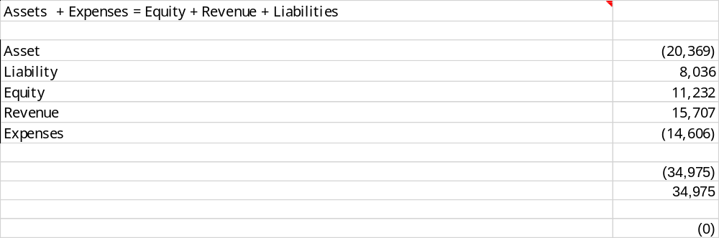
I would have to say even though I have had experience with cashflows in the past, ScanTech cashflows were definitely very complicated. I will need a few more party invitations to get to know these statements.
Ass# 1 Step 6

My Three Top Blogs –

I have found Facebook to be the most effective online communicator with reviewing people’s blogs about their companies. As I scroll through them, I found the companies with which I could relate personally to. Below are my three top blogs

- Cafecocolo.wordpress.com – Accountonme

https://cafecocolo.wordpress.com/2019/03/23/my-company/

Hays recruitment was a very familiar company to me. My current position has dealt with this company locally. Here is some of my comments below:

This would be an interesting study as the market for these services would be needed in growth areas and the downturn in the market would negatively impact this company. It would be very interesting to read through the financials and then do some investigation around what major projects are also happening. I know during our boom in 2012 with the Curtis island construction that recruitment services were in hot demand.

- Saritakrathongaccounting.wordpress.com – Rita Sarita Accounting Blog

https://saritakrathongaccounting.wordpress.com/author/saritakrat/

This was another company that sparked my interest. I haven’t delved into the operating revenue or expenses of a medical company and would find these figures a great learning experience. My comments as below.

There is always hype on the news about pharmaceutical companies over charging on medication and it would be very interesting just how much money (if any) these companies make and what the turnover revenue would be. I would also like to see what liabilities the medical companies had. I will be very interested to know if this company is listed on the ASX and the popularity of the main medication they supply.

- Chris – The Balance

https://primedfinance.wordpress.com/

Chris gave me the curtesy of liking and commenting on my blog so I thought I would do the same. I’m glad he did as I was very impressed with his company blogging. His company is similar to mine which deals in the mining sector however on a much bigger scale. My comments are below

Your company is very impressive and I love from the annual report of the key highlights how in-depth they go. The key achievements highlight every possible action of the company. I was a little disappointed in mine as it didn't go into much details of the highlights and reasons for revenue increase. Your analysis on your company was so thorough and you have gone into a lot of detail. You have created some fantastic KCQs and I love the part of diversity. That is always a major influence factor in companies these days. Even the graphs tell of a business reality that streams into the billions of billions of dollars. I will follow suit and do some googling of the accounting standards as I can see you have found some valuable information. Thank you for sharing this information.

