Subject: ACCT11059 – Accounting, Learning and Online Communications.
Leigh Scherer
Topic: Assignment 2 – Step 3 and 4.

Thoughts and feelings on Step 3

Well what a feat… I can say I struggled enormously with this chapter. I think in total I read Chapter 4 at least 5 times. Three of those times was on holidays at Bargara Beach. There was so many different terminologies and formulas that I found I had to try and re-instate my company to understand them. This helped me immensely. I worked through each concept and every time I came to the terminology of FCF, economic profit or Operating Income (OI) or Net Operating Assets (NOA) I would work through re-instatement of my financial statements to understand these terminologies.

A wonderful joint venture was the videos that Maria posted on re-instating the financial statements. I watched one of these (over Easter and eating chocolate) each night and at the same time re-instated my company financial statements. I don’t think I could have done the cash (split between O&F) or worked out the tax benefit/expense without the help of these videos. I found the footnotes really helpful in my annual report as they break down each component at the end of the report. Hopefully I have allocated them all correctly as I must admit I went through each line item a few times. I was stuck on amounts on deposit at banks and ultimately decided this was a financial asset. I also used the free space at the bottom of my spread sheet to work out each hint to ensure that the figures balanced to either the original statements or as mentioned in the videos. I also used this space to practice with the different formulas of FCF, Economic profits etc. My company seemed to a massive Economic profit in 2018 however I think this was due to the higher revenue and profit which they realised in this year.
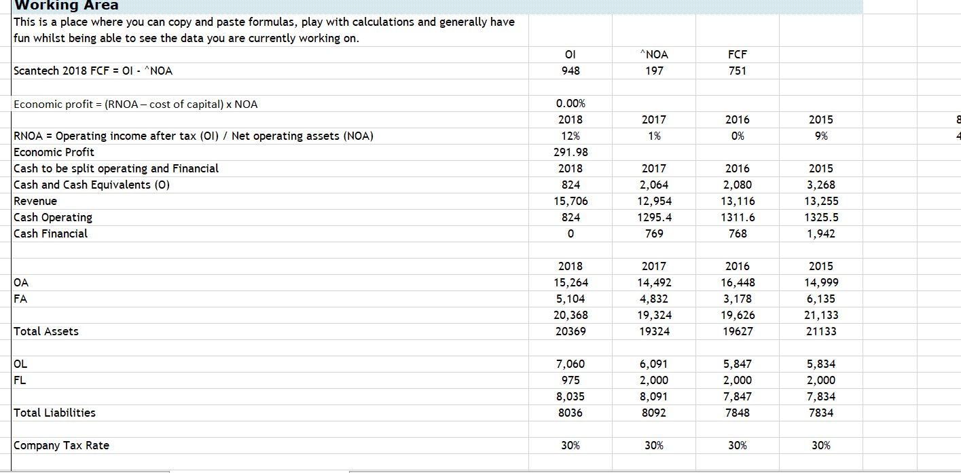
I am a numbers person and love the surge of excitement when the numbers balanced. Maria gave some great hints about matching the debits to the credits. It took me a while to understand this concept and I had to change the formula to match the below as it was a different scenario to Maria’s company.

I also find as I give feedback on other peers re-instated financials, I am also learning how other companies operate and interpret their financial realities. I reached out to Facebook a few times for comfort and support. Breeze and Paul helped me work through a few items of whether it was financial or operating.

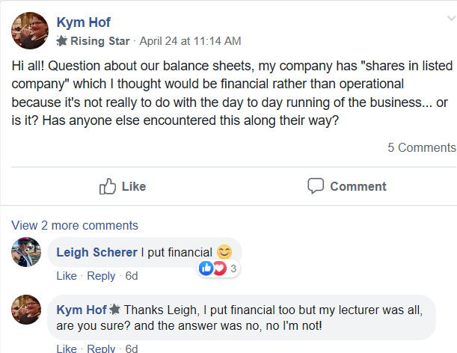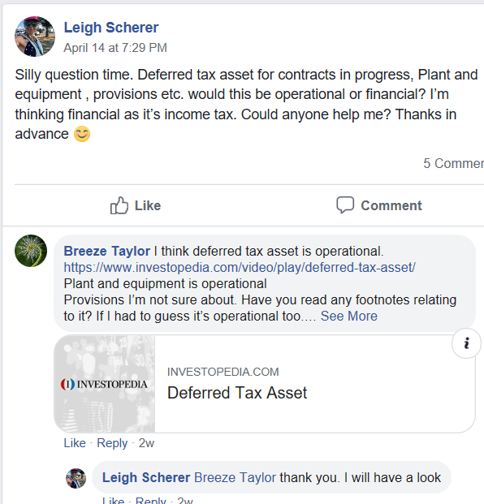

I was feeling a little fearful when I saw people had left me feedback. I was thinking to myself ‘’oh what if I had totally messed it up and they give me a three-page feedback form’’ or ‘’maybe I had done the whole thing incorrect’’. I was really appreciative of the feedback they had left and that they had taken time to look over my work. I went through each feedback form and made the changes they had highlighted. It gave me a boost of confidence that I hadn’t done such a bad job.
I have included below my feedback forms which I gave and also the feedback forms I had received and responses I had given.
PEER FEEDBACK SHEET: ASS#2 Step 4
Feedback From: Stuart Hentschke
Feedback To: Leigh Scherer .

 | My Comments
Step 3 | SOCIE: All correct. You have listed opening and closing balance, linked to correct cells and total formulas are used when required. I couldn’t find a word document or any explanation of why items have been classified in a certain way.  Balance Sheet: I agree with your allocations of O and F. I did notice that  Doesn’t equal  It’s out by up to $1000. Using (Ctrl + `) I highlighted a problem that the deferred tax asset and your deferred tax liability had been type in rather than linked, I thought that this would solve the rounding issue but it didn’t.  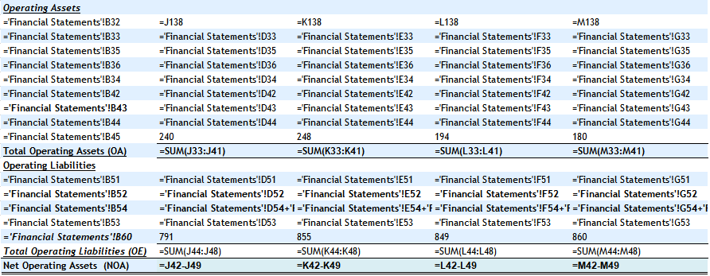  Looking to the original financial statement I noticed that in the years 2018 and 2016 a + 1 has been included (Presumably to balance due to rounding issues).  I removed these + 1 and I could balance the total assets and the total liabilities to original but there was a problem with equity not balancing. You might need to adjust your original balance sheet and get it to match your annual report (without the + 1) prior to allocating your O’s and F’s. Allow a few decimal places to check that the numbers are correct if needed.  Income Statement: First check your OI + NFE = total comprehensive income in the CI in original financials all matched nicely. Next check was that O CI + F CI matches that in restated SOCIE CI. This also matched nicely although I noticed that in your restated SOCIE the total for ‘other comprehensive income’ wasn’t listed (it was only in the original SOCIE). It might not be necessary, but I would list this total to make it easier to identify. Your allocations of cash and the tax benefit appear to be correct.
Restated Statement of Changes in Equity
Balance Sheet
Income Statement
Commentary and discussion with others

(Note: You may wish to give some comments
on their Excel spreadsheet)
Step 4  Individual feedback with other students | Not Provided.
Overall ASS#2 Steps 3 & 4 | Do you have a word document to explain why you classified each item the way you have? I have agreed with the listings based on the titles alone, it would be good to have some additional information about how you made your decisions. Please let me know if any of my comments don’t make sense. Overall, I think that you have done a great job, well done!
Note: Please use this sheet as a guide.
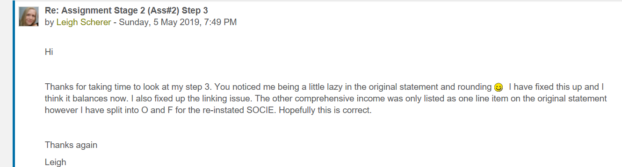
Feedback From: Shania Macnicol
Feedback To: Leigh Scherer
 | My Comments
Step 3:  - Restated Statement of Changes in Equity  - Balance Sheet  - Income Statement  - Commentary and discussion with others  (Note: You may wish to give some comments on their Excel spreadsheet) | Restated Financial Sheets:  - Your formatting is good, just a quick suggestion though, you only need to underline underneath the numbers.  - Everything is linked correctly from what I have checked  - Lots of good working out at the bottom of the sheet, good job!  Commentary:  - I have read another step three that also mentions going away on holiday. I hope you enjoyed it.  - I also struggled to get through this step without constantly referring to the chapter and Maria’s very helpful videos.  - I have found that a common trend so far is the amount of people struggling to complete the classification of accounts into O and F. It’s a great feeling not being alone especially when everyone is struggling in the same criteria.  - I am not much of a “numbers” person, but that is a big reason why I am so thankful to excel for being a calculator that my brain could not be.  - Make sure you include this section you have written in a word document that gets submitted in week 9.
Step 4:  - Individual feedback with other students | - I noticed that you mentioned that you have completed this, I just could not find it in the link you gave on Moodle sorry
OVERALL COMMENTS | Overall, you have done a great job completing this step. Just a couple of things to tidy up and just to remind you, make sure you put your step 3 reflection into a word document for when you submit it. If anything is confusing, please feel free to email me any questions you have. Really good job!

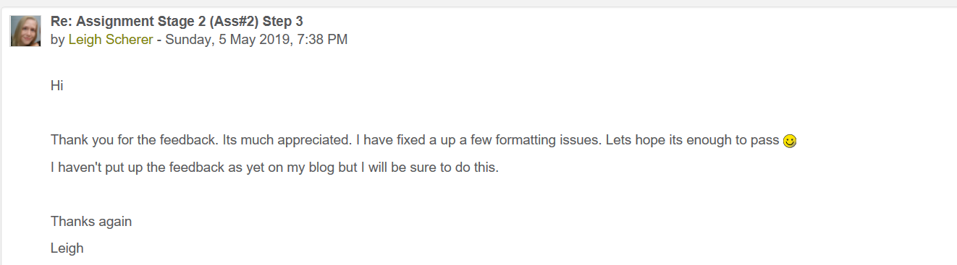

PEER FEEDBACK SHEET: ASS#2 Step 4
Feedback From: Kayla Skrinnikoff
Feedback To: Leigh Scherer .

 | My Comments
Step 3 | Your restated statement of changes in equity all looks correct. The formulas seem to all be correctly linked back to the original financial statements. Also, your closing balance matches the closing balance in the original statements so good work.  Again, with your restated balance sheet, all formulas linking back to original figures seem correct. Involving the layout, perhaps you could make sure all bolded headings are consistent with bolding the figures that follow. However, also take off bolding of figures that aren’t totals such as ‘Other Provisions’. Quite a few of your activities are bolded when they shouldn’t be. The checks balance out to a degree. It is clear that many of your figures are out by $1, perhaps this may have something to do with formatting - You should go over this.  Everything looks correct and checks out in your restated income statements so well done!
Restated Statement of Changes in Equity
Balance Sheet
Income Statement
Commentary and discussion with others

(Note: You may wish to give some comments on their Excel spreadsheet)
Step 4  Individual feedback with other students | N/A
Overall ASS#2 Steps 3 & 4 | Overall, you have done a great job with your restated statement of changes in equity and restated income statements. However, you will need a little more work with your restated balance sheets. You’re on the right track and I’m sure you’ll fix everything up nicely.
Note: Please use this sheet as a guide.
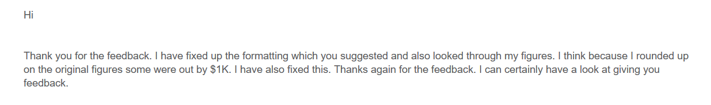

Below is my feedback to my fellow peers.

PEER FEEDBACK SHEET: ASS#2 Step 4
Feedback From: Leigh Scherer
Feedback To: Zoe Anderson Atlas Pearls .

 | My Comments
Step 3 | Your re-in statement of financial statements has been done very well. I was able to follow through the formulas and match the equity on your Restated Statement of Changes in Equity to your Equity on the balance sheet. I was also able to match your  Total comprehensive income/(loss) for the period amount to the same amount on your re-instated income statement. Your company made a couple of major losses in 2018 and 2015. It would be interesting to know what contributed to them. Maybe by working out the economic profit you could see if they made some investments in those years. I used the bottom of my spreadsheet to work out a few of the terms we used in chapter 4. It gave me comfort seeing how you worked out the Cash and split between O & F and also the formula you applied for the tax benefit as I used the same format.
Restated Statement of Changes in Equity
Balance Sheet
Income Statement
Commentary and discussion with others

(Note: You may wish to give some comments
on their Excel spreadsheet)
Step 4  Individual feedback with other students | I loved reading your thoughts and how you broke down each step. I found I had the same challenges and went to Facebook for some support. Such a good tool. You have given me some extra thoughts to expand upon in my assignment. Job well done. 😊
Overall ASS#2 Steps 3 & 4
PEER FEEDBACK SHEET: ASS#2 Step 4
Feedback From: Leigh Scherer
Feedback To: Georgia Muir .

 | My Comments
Step 3 | The tax expense was showing zero in the income statement. I thought maybe this was because the company had made a loss. My feedback is below.
Restated Statement of Changes in Equity
Balance Sheet
Income Statement
Commentary and discussion with others

(Note: You may wish to give some comments
on their Excel spreadsheet)
Step 4  Individual feedback with other students | Hi. I thought I would leave some feedback for your step 3. I think we were both lucky we didn't get some weird looking assets or expenses. I did note a couple of things though. There doesn't seem to be a tax expense calculation. Maria shows on the re-instating the income statement how to break out and apply the tax expense or benefit and times it by the company tax rate. Does this not apply to your company? I have included below a small snippet from my spreadsheet  Net Financial Expenses  Finance Income (F) 48  Other Income (F) 256  Borrowing Costs (F) (93)  NFE before tax 211  Tax Benefit (63) This is the NFE before tax x 30% company tax rate.  Maybe because your company made a loss, they don't need to pay tax. However, they may have received a tax benefit.  Sometimes so confusing.  Another thing to mention is the use of the free space. I used this space to work out a few equations to  RNOA = Operating income after tax (OI) / Net operating assets (NOA)  ATO  Sales/NOA  Might be worth utilising this space and checking the formulas match to the front page.  Well done :)
Overall ASS#2 Steps 3 & 4
Note: Please use this sheet as a guide.

PEER FEEDBACK SHEET: ASS#2 Step 4
Feedback From: Leigh Scherer
Feedback To: Karen Howard .

 | My Comments
Step 3 | Hi Karen, I thought I would provide some feedback on your step 3. There are a few things I noticed in the Restated Statement of Changes in Equity. A couple of the cells aren’t linked to the original statements. I think part of the assignment was that everything had to be linked even the categories. My other question was around the below  Other comprehensive Income of $-377. Was this operating or financial? There were no sub totals so I wasn’t sure.  My other question was around the total for comprehensive income. It was shown as the below  EQUITY AT END OF YEAR 11,750. Should this read differently?  I also had a few questions of the Income finance statements.  I found I had finance income in the Revenue portion in the footnotes. Would your figure below include any finance income?  Other revenue/income 1,203  Should there be a tax benefit calculated?  I used the free area down the bottom to balance a few of the equations as shown on the videos.  Other than that job well done 😊
Restated Statement of Changes in Equity
Balance Sheet
Income Statement
Commentary and discussion with others

(Note: You may wish to give some comments
on their Excel spreadsheet)
Step 4
Individual feedback with other students
Overall ASS#2 Steps 3 & 4

I have also got back into the swing of peerwise. I slackened off while I was madly trying to concentrate on this chapter.
Very exciting we are over half way through this term. I can see the light …

Happy learning

