Assignment Step 3 – ACC11081
My Company – Grammer
Well I might as well start with my initial thoughts of my company. It actually took me at least ten minutes to figure out how to read the website in English. Grammer is a German company that develops and manufacture components and systems for car interiors and also driver and passenger car seats. They have companies in over twenty countries throughout the world. However not in Australia. During these ten minutes I was in a state of panic. I thought to myself this can’t be correct. Why have I been given a German company and not understand one single thing on their website. How was I going to transcribe their annual reports into financial statements? I couldn’t even find their annual reports or any German words that would be similar. After these ten minutes of panic I found a little button that said EN. Then in awe the whole website turned to English. During a conversation with Martin we discussed the complexity of this company. It certainly will be more of a challenge than Scan Tech which I had last semester. The annual report alone is over two hundred pages.
Grammer has secured markets in a range of commercial and private vehicles including rail, buses, construction equipment and trucks.

While exploring their website (now I can read it) I discover the below award
https://myseatlounge.grammer.com/news.html


This company seems like a prestigious company and I am looking forward to delving into this one. Last semester while reporting on Scan Tech I couldn’t find much information that supported their financial information or the highs or lows of the period. I think this company will give me greater experience in consolidating their financial information but also provide information which has driver these financial highs and lows. I was quite surprised by their executive management team. Manfred Pretsche is the Chief Financial Officer and Chief Executive Officer of Grammer. It’s not very often I see one person supporting both of those roles. This website has so much informative sections. It’s also relevant as most articles are dated this year.

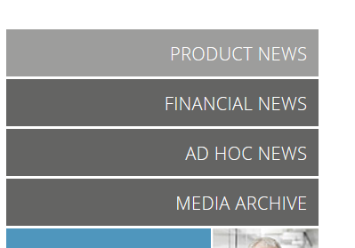
Below are a few snapshots of their financial section. There is 48 pages of updates.

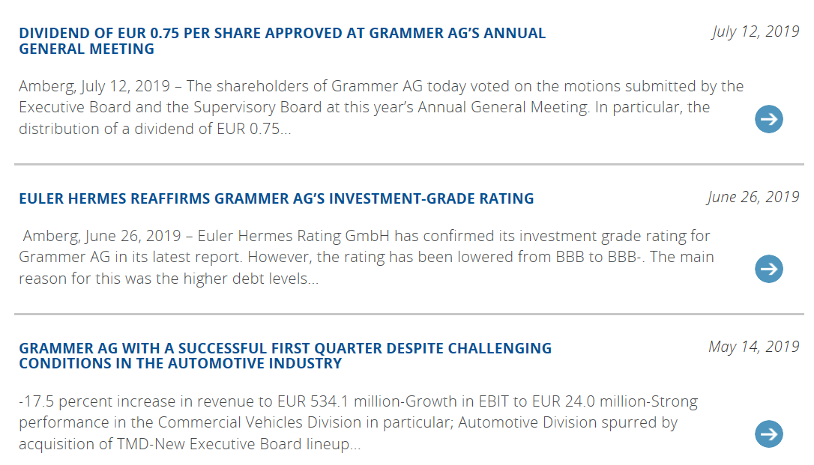
I have included some links below for videos of their products
https://www.grammer.com/en/company/innovation.html
https://www.grammer.com/en/products-markets/commercial-vehicles.html

By the end of this semester it very likely I will be more informative about cars then my husband and he has studied them for over twenty years. I leave you with a picture below of one of their interior drivers’ seat. I have a few hundred pages of annual reports to read.

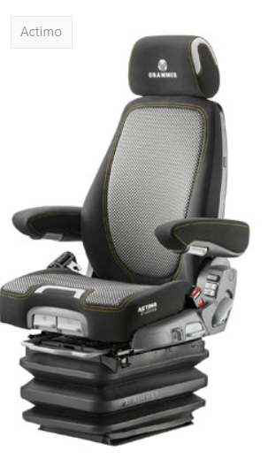
Annual reports
As a read through the reports I’m a little unsure what information to focus on. There is 182 pages of company information and financial data. It was a little overwhelming. So, I decided to focus on the highlights over the last two years. The 2018 annual report starts with financial highlights from 2018 and 2017. Even though the report is in Euros I am still hoping to follow the financial trail. It’s a high-level detail of revenue, profit and loss and assets. I’m a little curious how much a Euro dollar converts to an Aussie dollar. The annual reports list group revenue in 2018 was 1,861 million Euro. I find out that one euro equates to 1.63 dollars. Therefore 1,861 million would equate to 3,033M AUD. There was also a similar group revenue of 1,786 Euro in 2017. A slight increase from 2017 to 2018. After learning quite a few ratios in the last semester I could easily identify some of the acronyms the annual report was detailing.
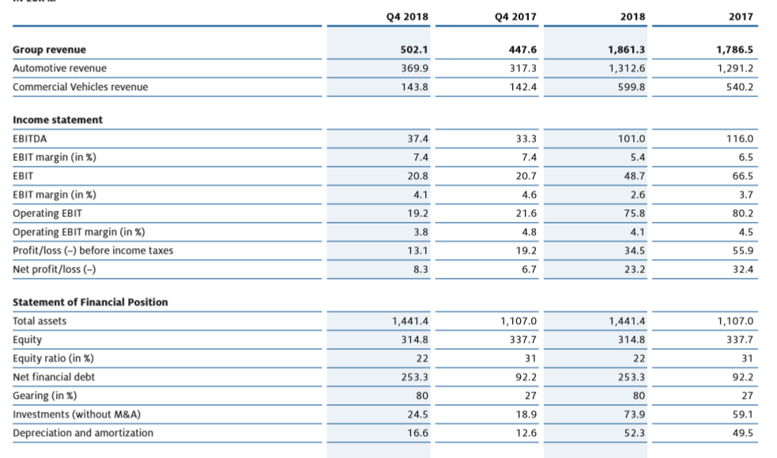
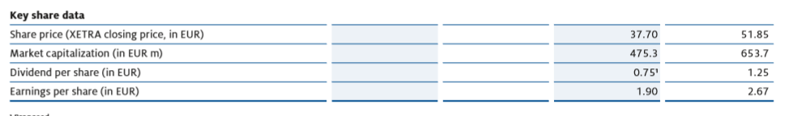
The income statements list earnings before income tax, depreciation and amortization (EBITDA). You can see 2018 have a lower EBITDA of 101M EURO. It then shows the earnings before income tax (EBIT). We did this exercise in the last semester where we separated the financial and operation assets, liabilities, revenue and expenses. After deducting the income tax from the earnings Grammer has an EBIT Margin on 2.6% in 2018 and 3.7% in 2017. The above table also lists the operating earnings before income tax. From an operating perspective Grammer’s operating EBIT is a lot higher at 75 M EURO. In both years Grammer has made an operating profit of 23M EURO in 2018 and 32M EURO in 2017. I’m a little curious what the 2016 and 2015 years invested in retained earnings. From the 2015 and 2016 results below you can see a steady increase in revenue between the four years, however a decrease in net profits. Net assets have increased each year however the financial debt has increased in 2018 which could have contributed to the lower gross margin for 2018.

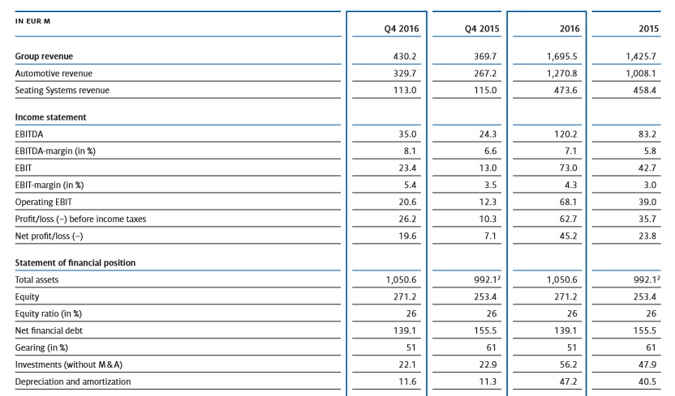
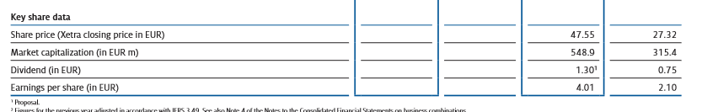
The share price has also decreased in 2018 after a steady climb from 2015.
I find these annual reports much more detailed than the company I had last term. I can easily identify the highlights from 2018 and I’m going to suggest the higher debt was from the below acquisition


Some other interesting facts of Grammer as I read through the annual reports

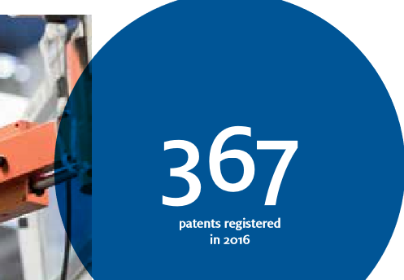
I could continue with 182 pages of information, unfortunately there are other assignments to finish. This is a very impressive company and with 14000 employees in 19 countries worldwide with forty companies I can see why this company has been successful in its endeavor’s. As I continue to discover the financial stability of this company I will endeavor to update through my blog.
Assignment Step 4 – ACC11081
I have worked with chart of accounts for the past twenty years, but the personal involvement of my own revenue and expenses seemed a little daunting. I can say though from the outset we need a little more discipline around food purchases. I am going to attribute the small profit to a five-week month. It’s certainly not us spending too much money. Maybe. My chart of accounts was quite basic and I could have dug a little deeper separating out the insurances and recreation activities. Below is my chart of accounts:
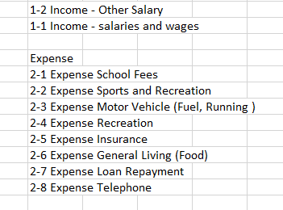
I noticed in Maria’s example excel that there was also a chart of accounts for assets, liabilities and equity however these weren’t used in the example. I wasn’t sure whether to apply any of these or even if I could from the data of my accounts. I have motor vehicles, a house and cash in the bank however it seemed the exercise was only looking at revenue and expenses and the profit or loss. These other items wouldn’t be found on an income statement. Hopefully someone can give me some feedback as to whether I have done this bit correctly. We certainly had a lot of transactions during the month of July which just highlighted what a busy month we had. Like I had mentioned above I was a little broad in my chart of accounts. We pay certain different insurances which I could have created sub accounts and I could have applied the same logic to loan repayments as we currently have three separate loans. I think the sheer volume of transactions overwhelmed me and I kept the assignment simple. The higher expenses in the month of July was school fees for both my children and my university fees, registration for the car and general living food expense. As these were once off fees for the year it reduced the profit quite significantly. If this was a business than these expenses could have applied the accrual basis of accounting. If I had of done this exercise in June it would have shown a more profitable month. There was a couple of transactions that I could apply the accrual basis of accounting. I pre-paid my car registration for a year. If I was to apply the accrual basis for this expense, I would recognize the expense for only that month in which it occurred (July) and spread the expense out over the others months of the year. The expense would need to be reduced (credit an expense account) and increase the assets called prepaid expenses. The other expense could be the upfront fee for university. The fee could be spread over the duration of a term and only recognized a portion per month. For a revenue perspective I am currently doing a shutdown and being paid overtime however this overtime is paid monthly and not until the month after. I could accrue for this revenue, that is increase a revenue account (credit of accrued revenue) and debit the asset accrued revenue for the overtime I have worked but not to be expected to be paid next month. My other challenges I faced for this assignment was re-linking all the expenses. After my first attempt it didn’t balance to all the revenues and expenses. I ultimately did the exercise twice for the figures to balance. I was also a little confused about accounting for the credit card payment expense. Would this be a double expense because it’s an expense paying for expenses on another card? For this reason, I didn’t include the credit card expenses in this example. It might have taken me another hour just to break these ones down. I thought I would enjoy that exercise a little more than I did. However, seems I need to watch what we spend.
Assignment Step 5 – ACC11081
Trial Balance of Grammer
I was a little anxious about completely this part of the assignment. My company is a little overwhelming with an annual report that is 182 pages long. However, I perused through the annual report and found the financial statements sections which was quick and easy to find. At first glance of the financial statements I noticed that this company had a lot more assets and liability than my company last semester. Even the sub sections of non-current and current had more listed items than Scan Tech. Grammer also had a separate comprehensive income which spanned over a whole page. At this point in time I must admit I was a little stressed about this part of the assignment. However, I realised as I worked through each item of the balance sheet and income statement, the fundamentals elements of accounting which I had learnt last semester were paying dividends. I could follow the items through each financial statement as I inputted them on the excel spread sheet and allocate to the relevant debit or credit side. My trial balance even balanced first time. When I mean balanced the balance sheet items balanced and the income statement balance matched the total comprehensive income after tax. This was the same figure that was entered on the statement of changes in equity.
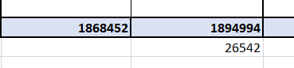
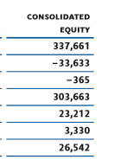
I was a little surprised that it had balanced first time. After I had completed this step, I took some time to go through each asset and liability and familiarise myself with some of this new language. The assets and liabilities sound very similar in nature so I will spend some time and hopefully find in the footnotes some differences relating to each. I jumped ahead a little and tried to complete the trial balance section of the all accounts with adding the formula in for the retained earnings. At this point in time I haven’t watched the video to confirm the steps. However, it did balance but would love to know the theory behind this step. I now feel very comfortable completing this step and knowing that completing a trial balance is a proven method of ensuring this systematic approach to accounting will always balance…. hopefully.

By Leigh Scherer

