Assignment Step 7 – ACC11081
Inventories
As I look back on my working career which expands over the last 20 years my experience with inventories has been little to none. Most of my careers have been in the service industry. I went from working at a travel agency to a personal trainer and then performing the accounts for a labour service company. Needless to say, it took my brain a while to comprehend the meaning of inventories. I haven’t worked in industries that held stock, did stocktakes or even accounted for inventory. Last year however my manager asked the project manager to take an inventory list of the all items that were kept in the containers at our workshop. This amounted to fifty thousand dollars. For the first time in my history of my current job (ten years) we had our first inventory balance. The transaction which he applied to account for this inventory stumped me but as I perused all the inventory materials over the past two weeks, the study guide, video lectures and extra videos, I started to comprehend the duality of this transaction. Below is the transaction he used:
DR Inventories (Balance Sheet)
CR COGS (Income Statement)
He was moving the cost of the goods purchased (which at that time was an overhead expense) to an asset of the balance sheet and reducing this overhead cost of the income statement.
Its been eight months since the inventories has been mentioned as we execute a shutdown however during the last eight months the company has certainly used these items of stock for providing labour services. If we were to do another stock take this amount would be dramatically reduced however more purchases have been made during this time. As you can see inventories doesn’t form a major part of this company and its day to day dealings. If I was to compare the two methods of inventory accounting methods, which is the periodic and perpetual methods, I would assume that this business would use the periodic method. This method does not look at monitoring stock movements on a day to day basis. The periodic method looks at stock levels at a certain point of time and uses the below equation to work out inventories.
Opening balance + Purchases – closing balance = cost of goods sold.
The perpetual method on the other hand looks at daily recording of inventories purchased and sold. Based on an electronic system the company knows what stock it should have on hand at any given time. However, stocktakes are also done to quantify these stocks. If the stocks are lower than the automated system there has been loss or wastage of stock. The accounting entry for this would be the write down:
CR Inventories (Reducing an asset would be a credit)
DR Expenses (Increase an expense would be a debit)

Let’s have a look at my company – Grammer
The first thing I noticed about the 2018 annual report for Grammer was that on the income statement there was only one-line item for cost of goods sold. This tells me that Grammer is using the perpetual method for recording inventories. This means they are recording on a daily basis the transactions between goods sold and brought or manufactured. The figure for inventories on the balance sheet is 190,992 EURO for 2018 and 158,020 EURO for 2017. They increased their inventory stock by approx. 30,000 EURO between the years. If I compare this to the 2016 year of 148 253 EURO there is a noticeable trend of inventories increasing each year. From reading through the annual report I can determine the increase in inventories in from the acquisition of company of TMD Group. The 2015 inventory figure remained steady at 145905 EURO
The percentage of inventory versus current assets would be 25% for 2018 and 13% of overall assets.
This compares to 2017 by 21% and 14%. A slight increase for 2018
There was also a similar trend in the cost of goods sold each year. The figures ranged from 1273,577 EURO to 1571,344 EURO between 2015 and 2017.

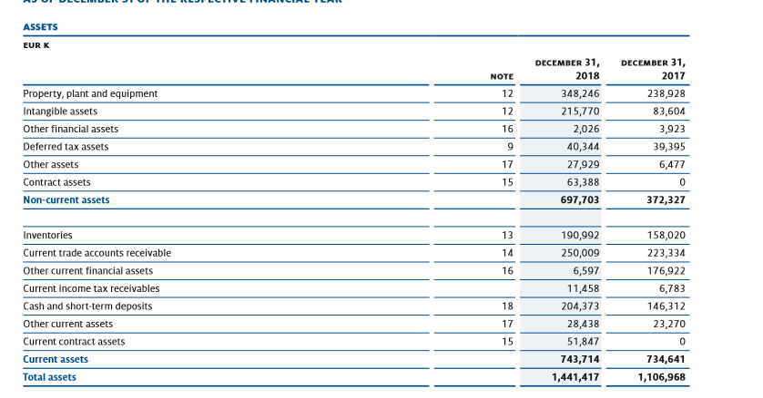
Inventories are classed as current assets under the presumption they will resold within twelve months of purchase and hopefully with a profit. During the video presentation and reading through the chapter guide, I learnt about four methods to valuing stock or inventory. I’m glad Maria used a visual method to explain these methods as I’m more of a visual learner. As per the AASB recording of inventories found on the website below:
https://www.aasb.gov.au
Inventories should be valued at the net realisable value – this is the market cost of the goods plus any costs of sale. I can see from the statement below that Grammer complies to this standard. It also uses the weighted average to determine the value of purchases made, During the video lecture and study guide we learnt about four methods of valuation of inventories.
They were:
Specific identification – This method applies items same in nature to have the same cost approach. This method is not warranted as there is a potential to overstate the figures
FIFO- Applies a first in first out method. Stock is valued at the price that the first stock was brought at until that stock is used and then moves on to the next value of stock purchased.
LIFO – Applies a last in first out method. This method is banned in Australia. This method will always apply the last in value first. This also can overstate the figures.
Weighted average – Takes the total quantity of goods and divides by total cost of purchases to apply a weighted average amount.

I found the weighted average method the easiest to understand. I work with averages and percentages all day long therefore I can see why companies would choose this method as it would be less complex. However, I was surprised that Grammer would utilise this method. Grammer develops and manufacture components and systems for car interiors and also driver and passenger car seats, bus, train and commercial equipment. To place a weighted average cost on items that may fit a passenger vehicle but would not fit into an excavator doesn’t seem quite right to me. Below shows a model of a cabin on the future. This model would differ in price to the base model or models with different features. How can you put an average weighted price on the components when the outputs or finished goods as described in the annual statements are so vastly different? It would be good to see what actual items are held in stock and the quantities and qualities of each stock item. Maybe this would give me more insight into why Grammer would use the weighted average method.
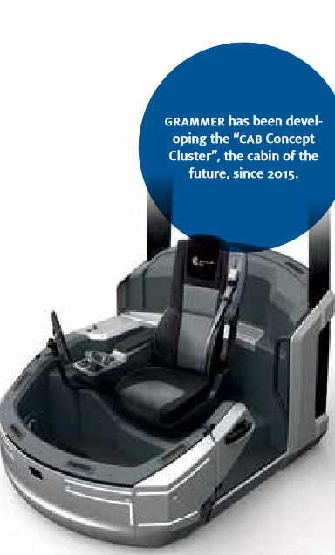
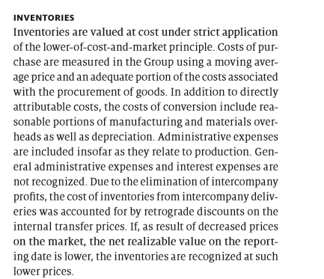
Also included in Grammer’s financial statement is the breakup of inventories as shown on the balance sheet. The majority of inventory is in raw materials and supplies. Below shows the 2018 and 2017 inventory breakdown. If I compare this to the 2017/2016 it shows the same trend in increasing inventories with the purchase of the TMD group. The percentage increases in raw materials, work in progress, finished goods and advance payments remain similar each year.
2018/2017
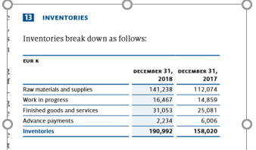
2017/2016
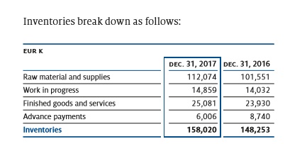
The transparency and the breakdown of the financial information shown in the annual reports provides great guidance in understanding the financial realities of this company. There are pages and pages of financial statistics and I wish I had more time to read every bit of information. From the layout and presentation of this annual report I don’t doubt that Grammer has technology and systems of the best quality to track the day to day movements of their inventories. I don’t think Grammer would struggle in managing their inventories. The only concern I would have is should a weighted average cost be applied to a car seat fitted in passenger vehicle compare to a car seat fitted into a luxurious airplane.

Assignment Step 8 – ACC11081
MYOB Set up
I think I may have gone a little overboard in the screen shot scenarios. I have included below the set-up screen shots. I know the assignment asked for two screen shots but below is the set-up phase.
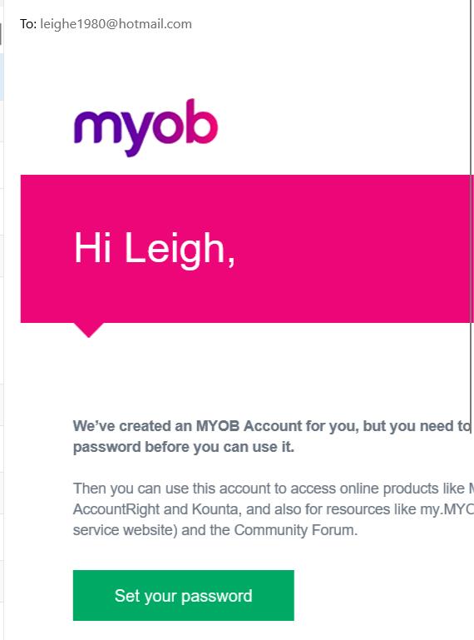

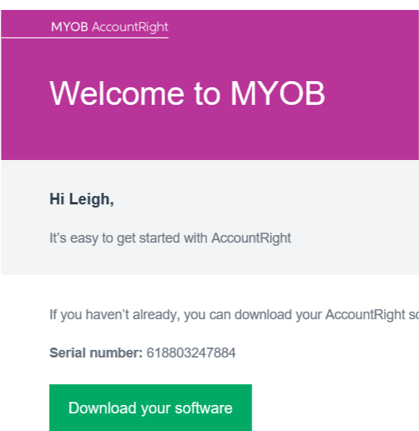

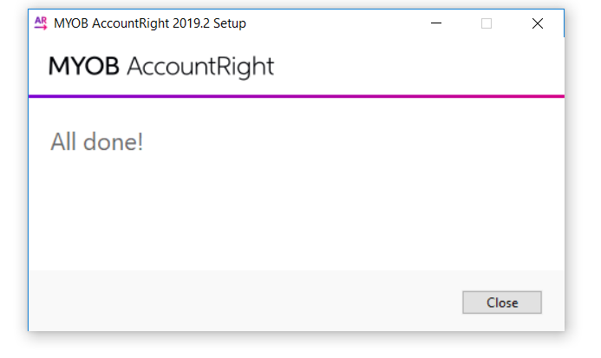
I decided to create my own file and I used my file to add transactions as I was going through the training stage. I will use these transactions and a few more for assignment nine. My company is call Leigh’’s Fresh Start. It’s a company that supplies well being products to customers including healthy food packages, face care products and spa massages. Below are the set up files for my company. I set up my company with the financial year ending June 2020 and the first transaction month being September 2019. I think if I have the choice to re-create my company again I would of chose an earlier month. As I was unable to back date transactions prior to this date I was only able to enter data on the 1st September as this was the date I started creating this file. You will notice all my transactions are either entered on the 1st, 2nd or 3rd September. A lesson learnt for next time. 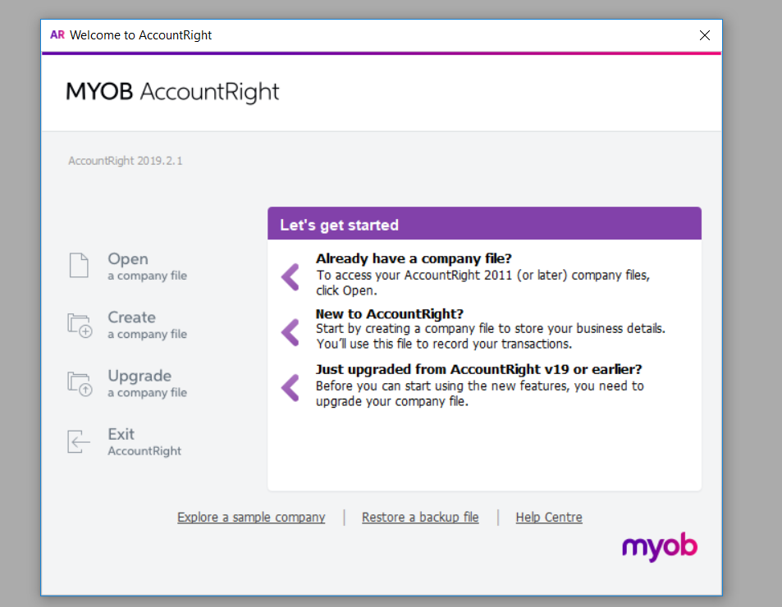
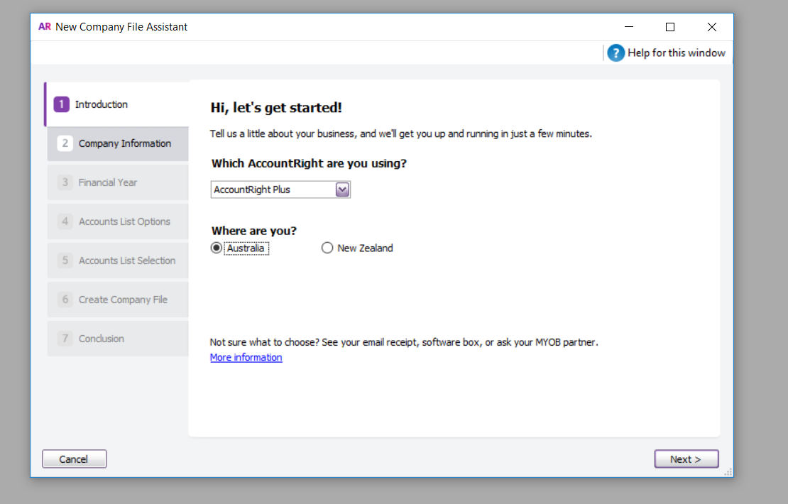
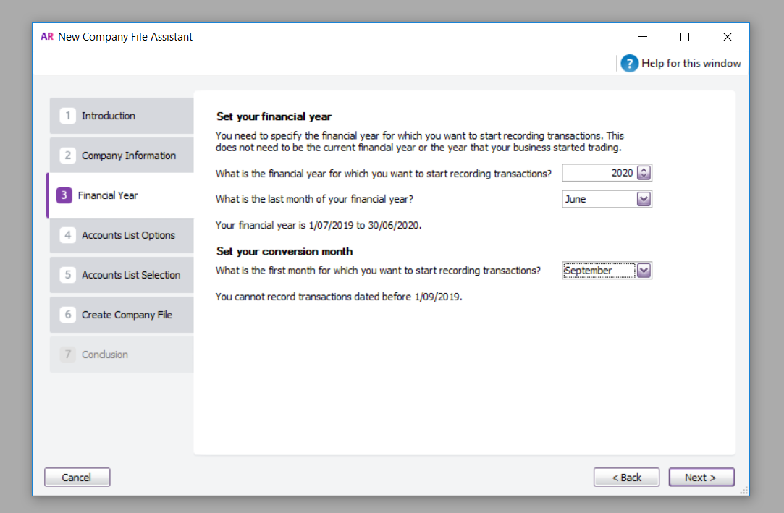

Below I nominate a retail set of accounts for my business as it provided goods and services to customers. I found the system quite easy to set up and follow. The training was very indepth and easy to comprehend.
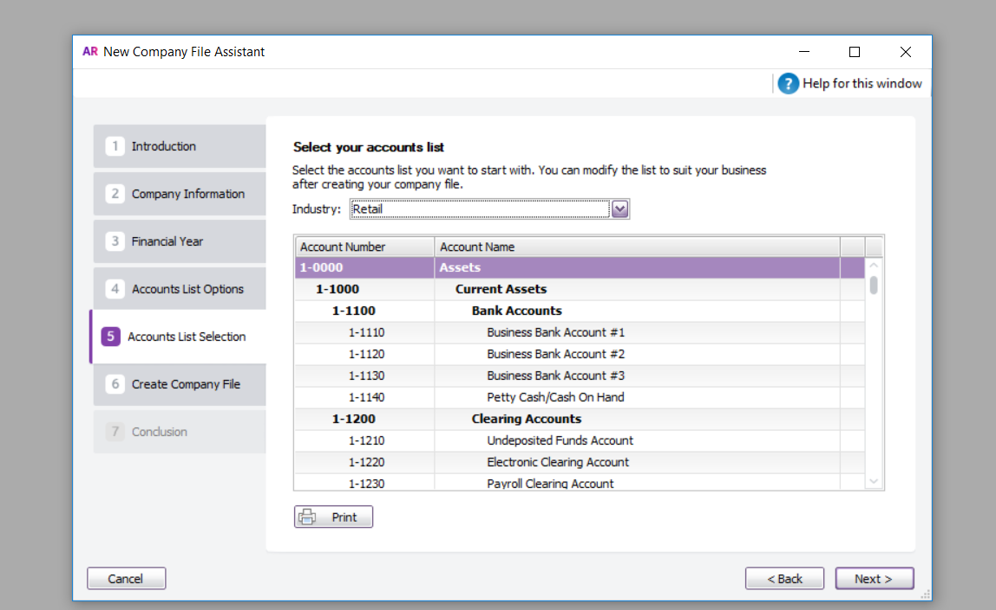

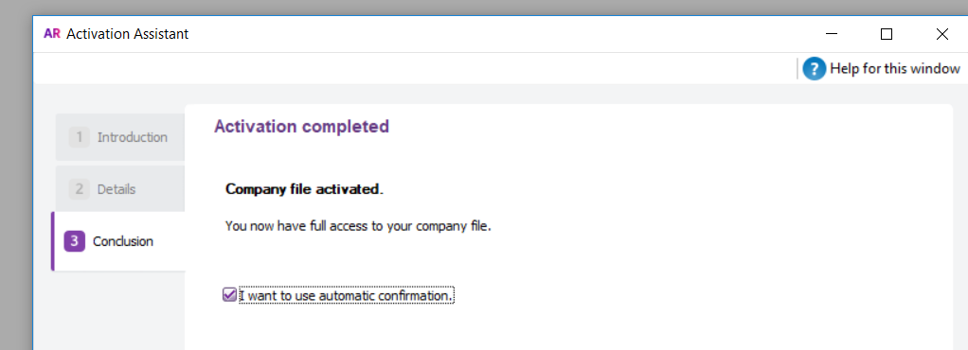

MYOB Training
Below is my company Leigh’s Fresh Start (also the name of my blog)
The command centres are listed at the top (a question of the quiz I was unable to answer correctly)
During the training we covered the 5 commonds below:
Accounts, Banking, Sales, Purchases and Card File.
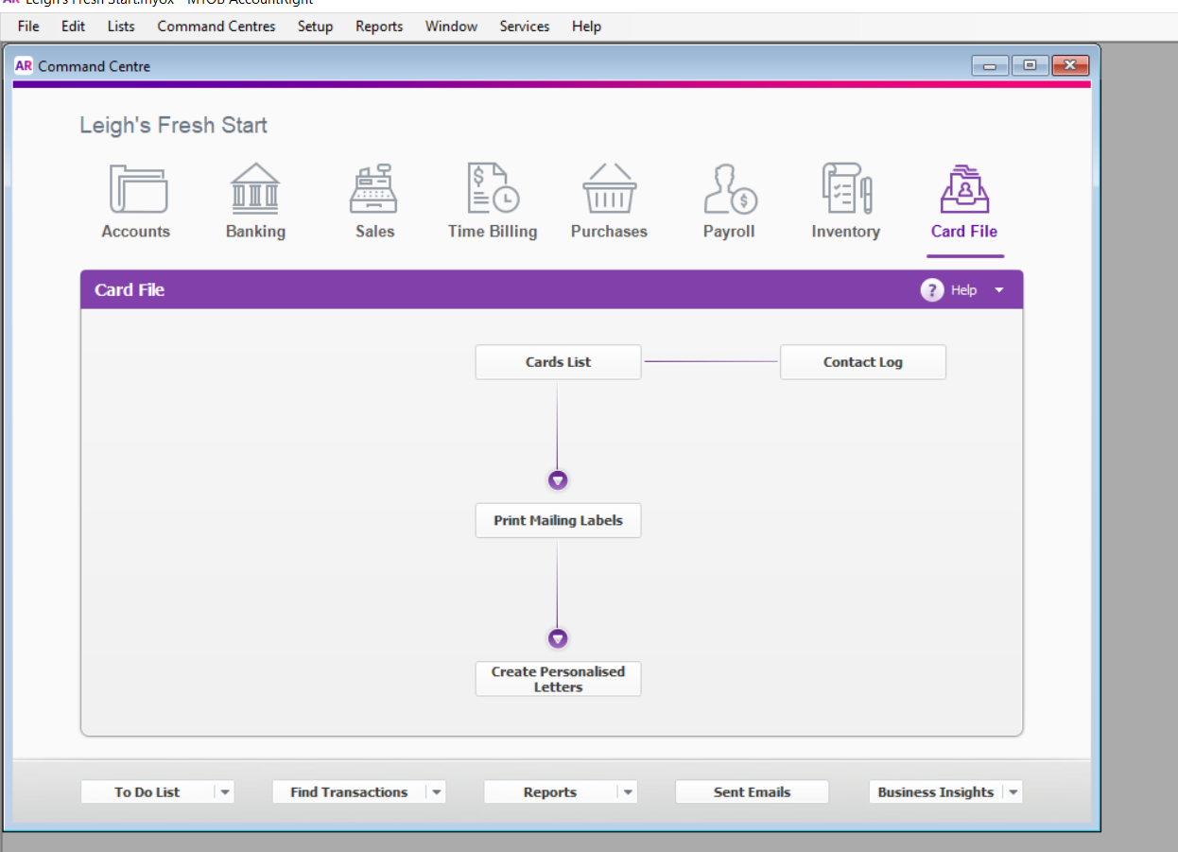
We learnt how to create additional users that could access the company file as per below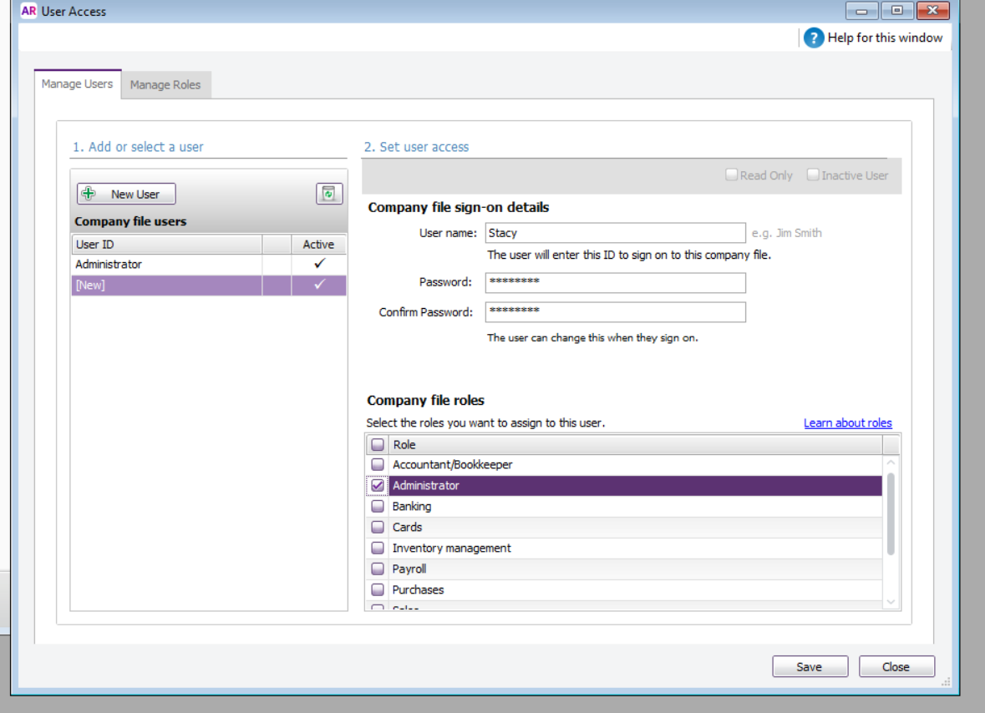
Then created a name of the bank account which is found under the accounts command and also deleted out accounts that weren’t needed.

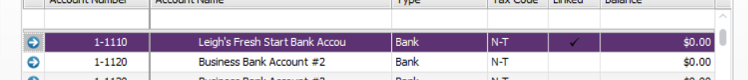
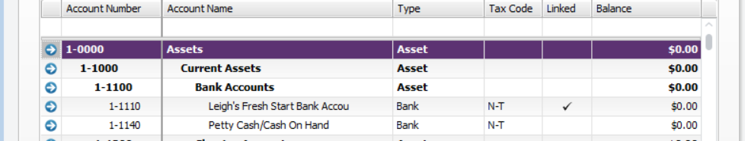
Created customers under the card file command and setting the payment terms and credit limits. The MYOB has many functionalities which included emailing quotes and invoices to customers.
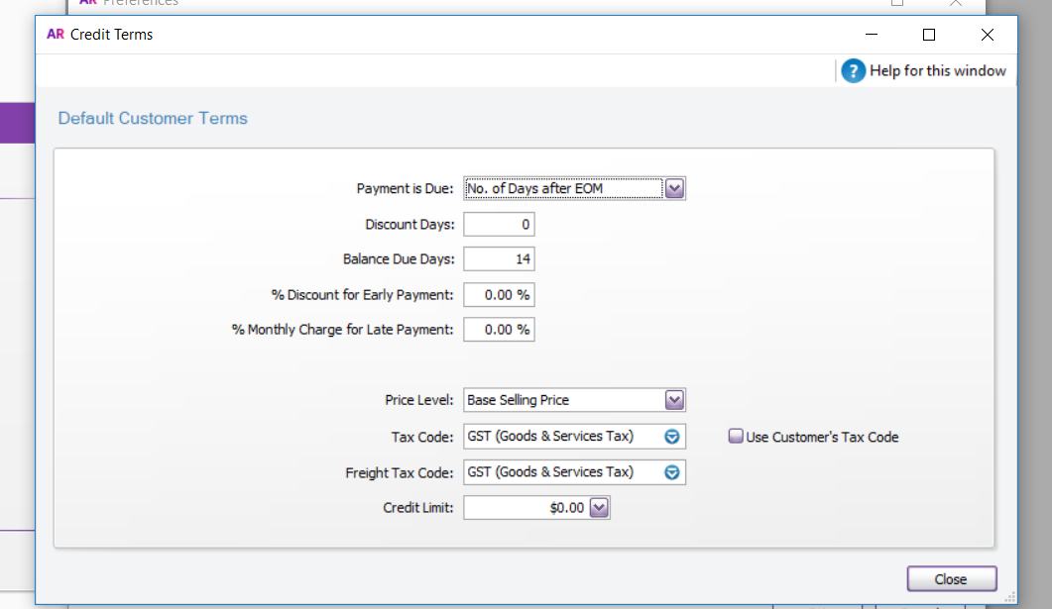

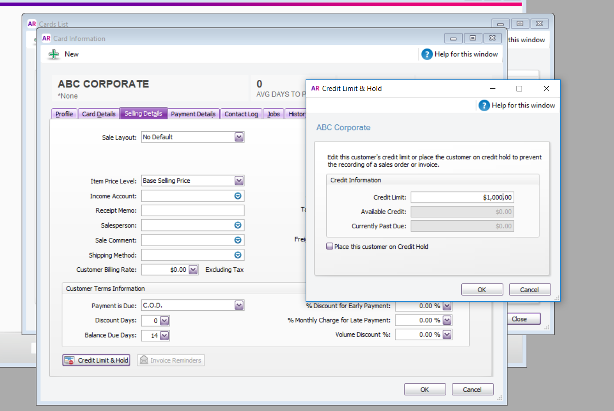
Suppliers were set up under the same card file command. 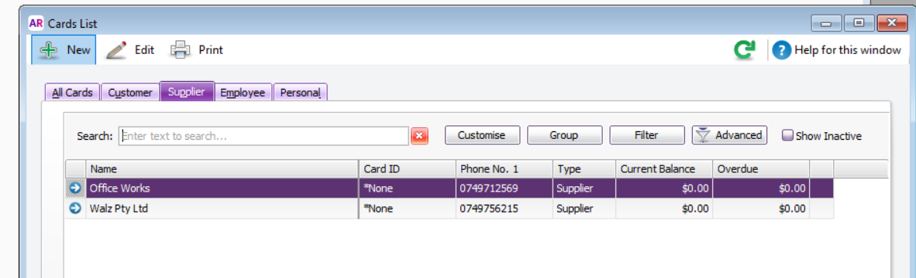
As this was a new company there was a requirement to enter the balances of each account as at the 1st September. I entered the below balances which will be displayed on the balance sheet.
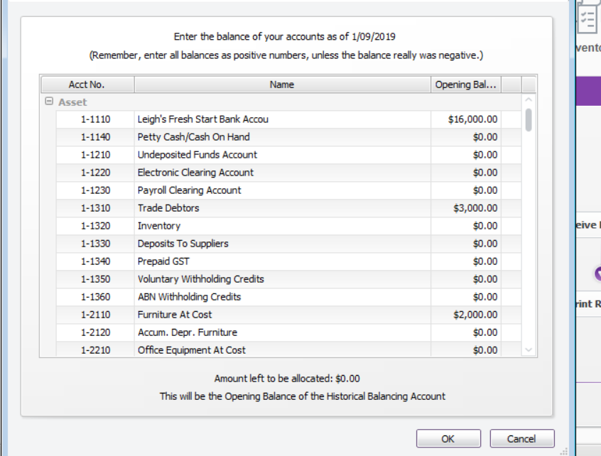

Trade debtors and creditors also needed balances created
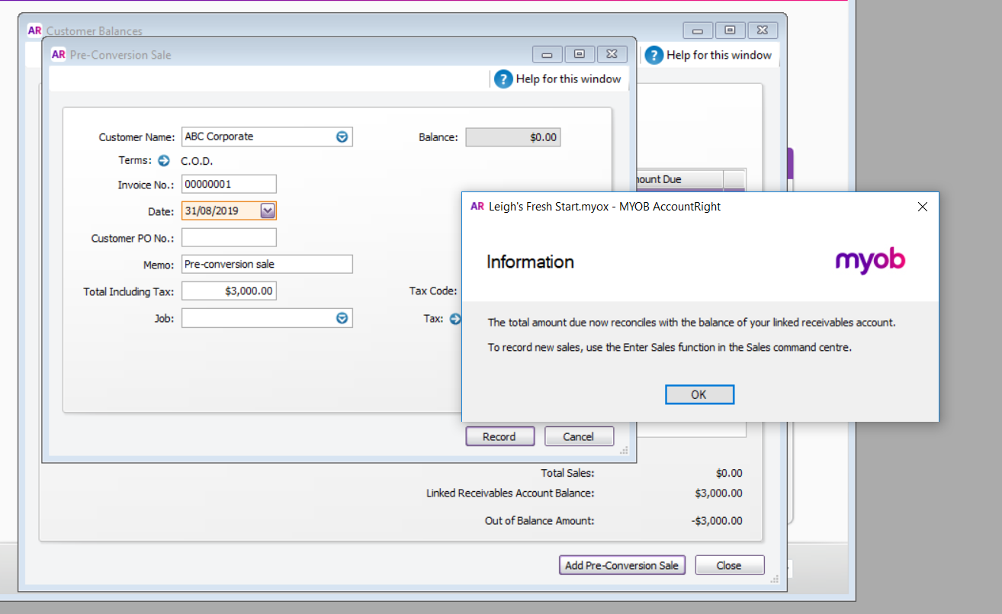

Enter unreconciled deposits and withdrawals to balance the last bank statement
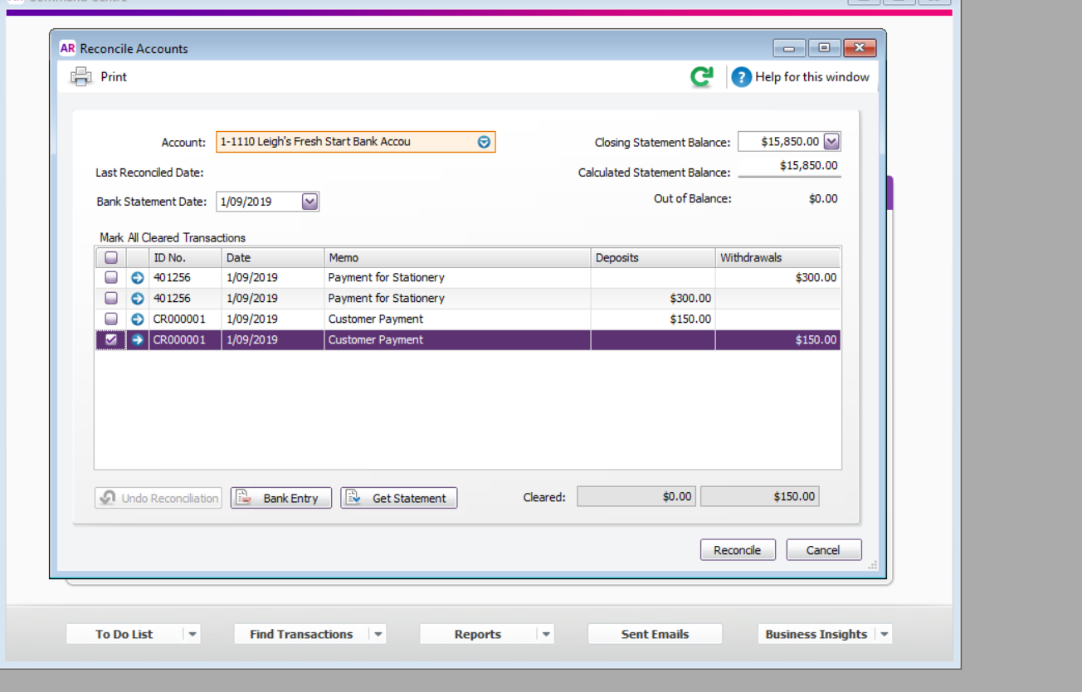

MYOB also had an option to setup preferences. Some of these preferences included to automatically print when quotes, order and invoices are recorded and also to set that transactions can’t be deleted. They must be reversed
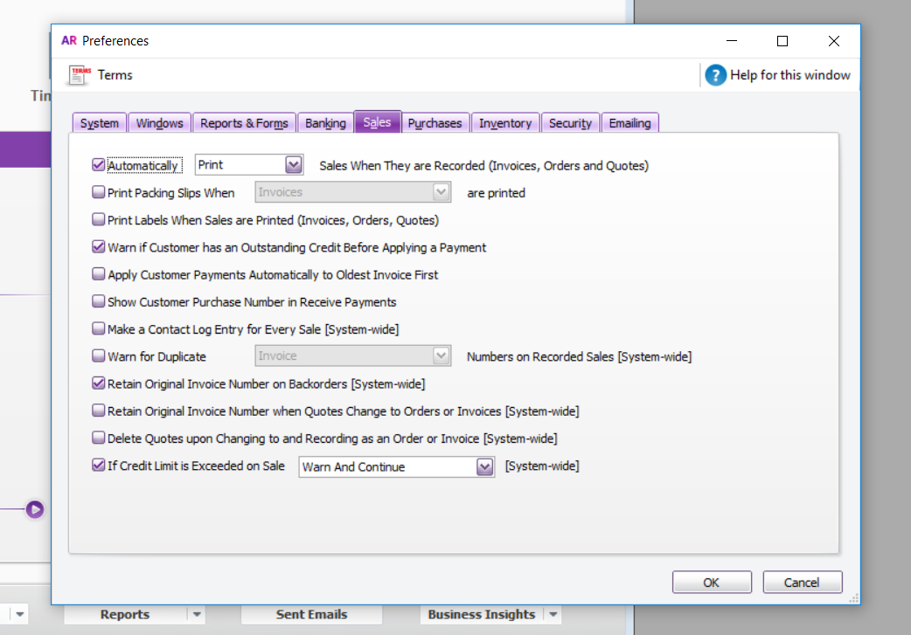
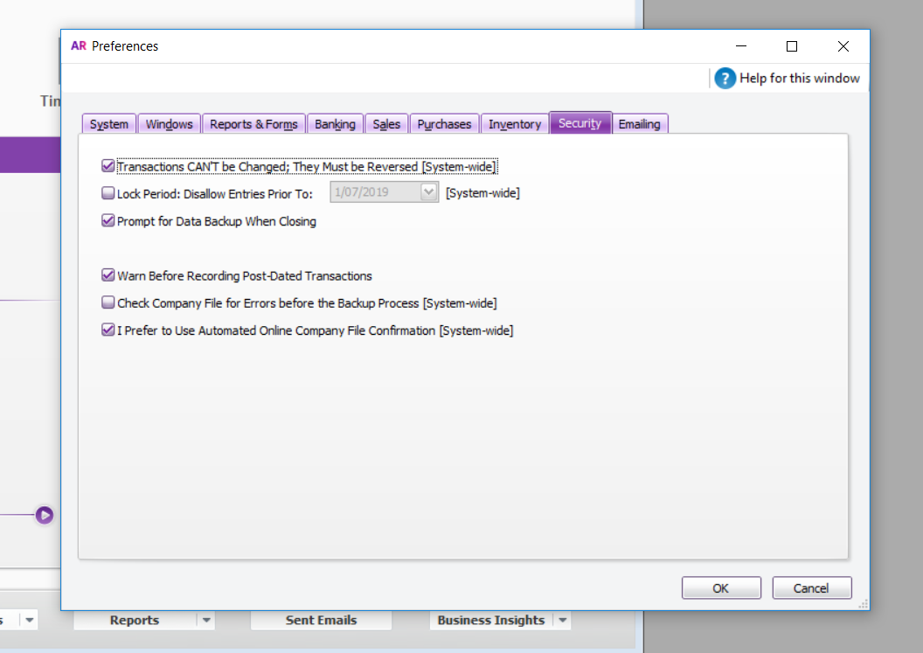

Completion of training
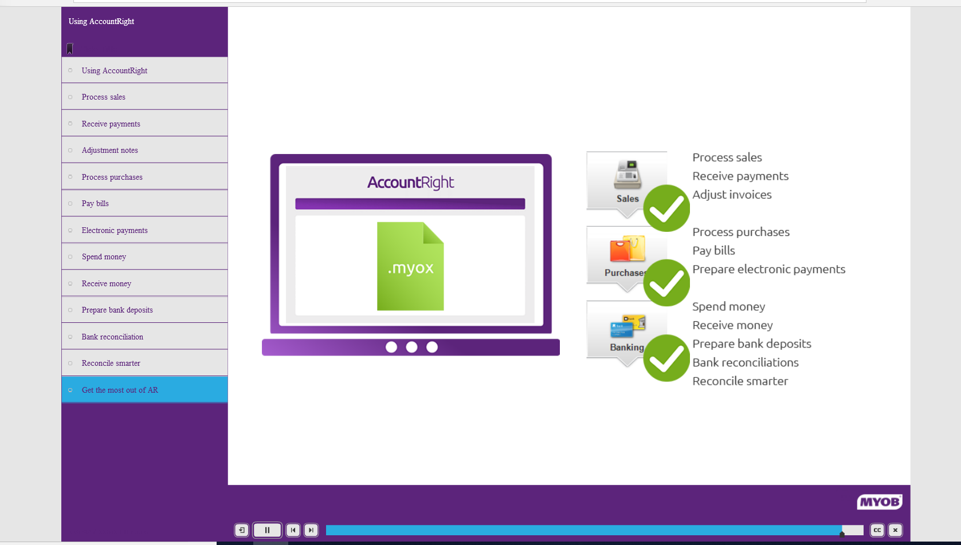
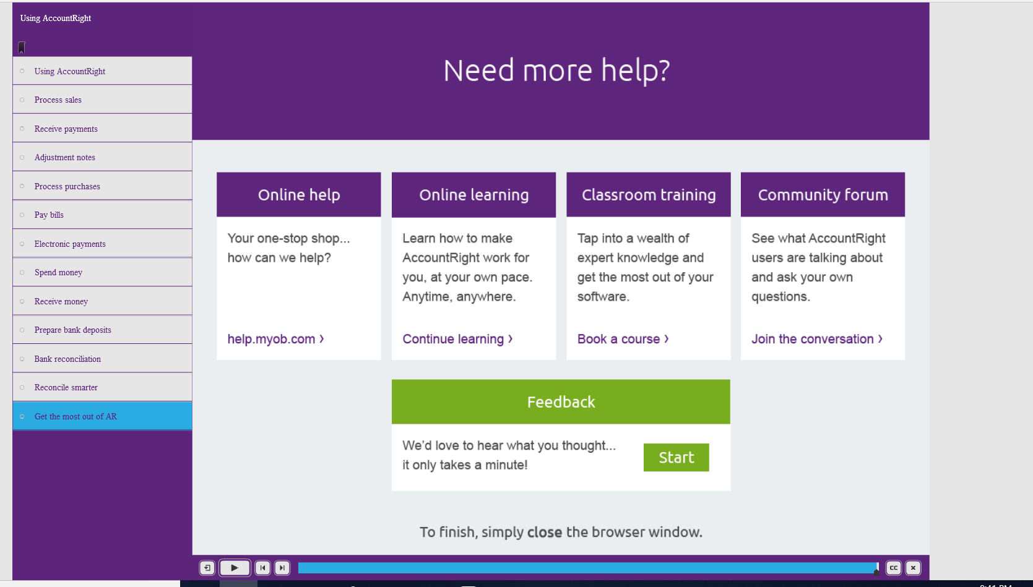

MYOB ONLINE Training Skills Test
I was a little disappointed with my results from the skills test. I took for granted my twenty plus years of experience and my thought process that most systems are quite similar in applications and thought I would breeze through this exam. My results show otherwise. I did find a few of the questions a little hard to interpret and even one that I didn’t agree with the answer. The below answer was incorrect. The screen shot for this one did not show correctly.
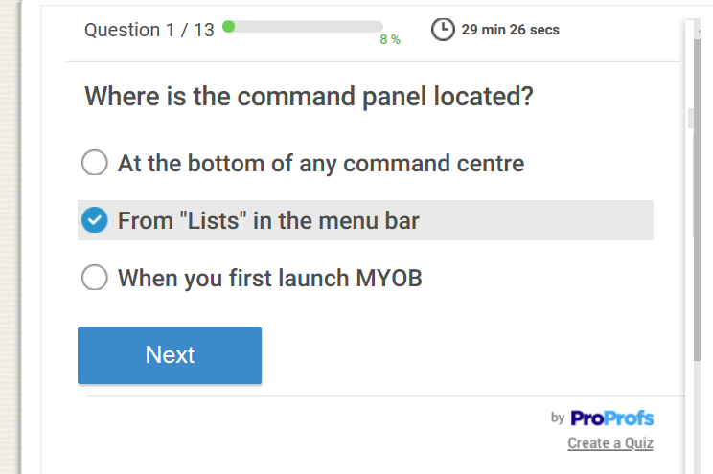
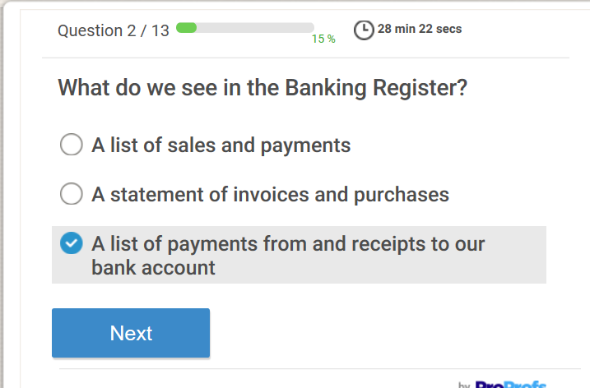
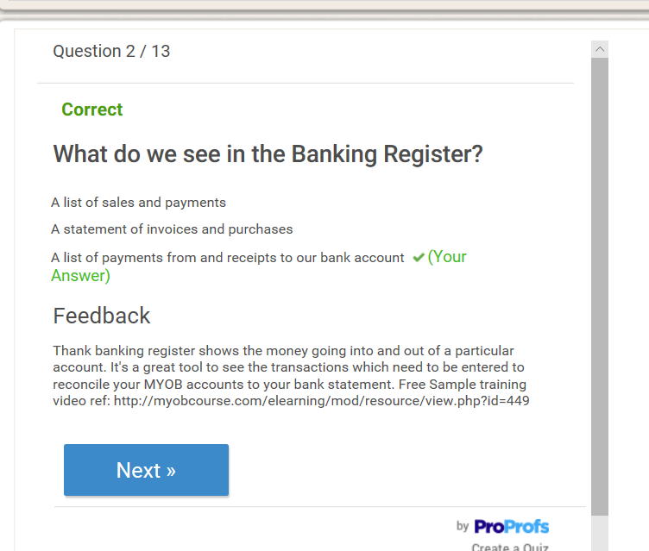
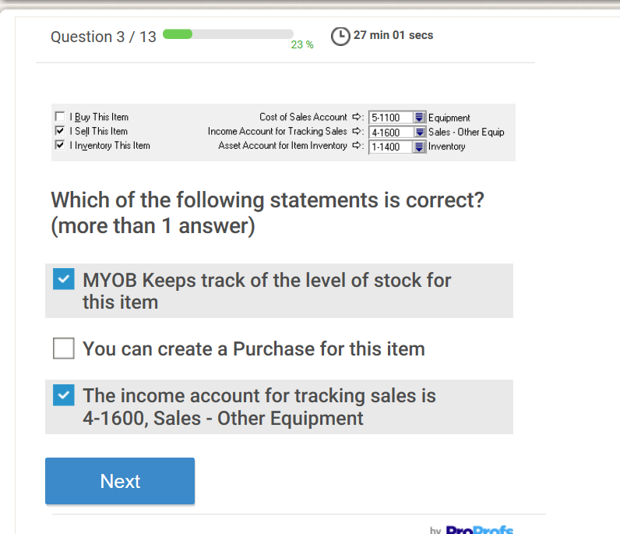
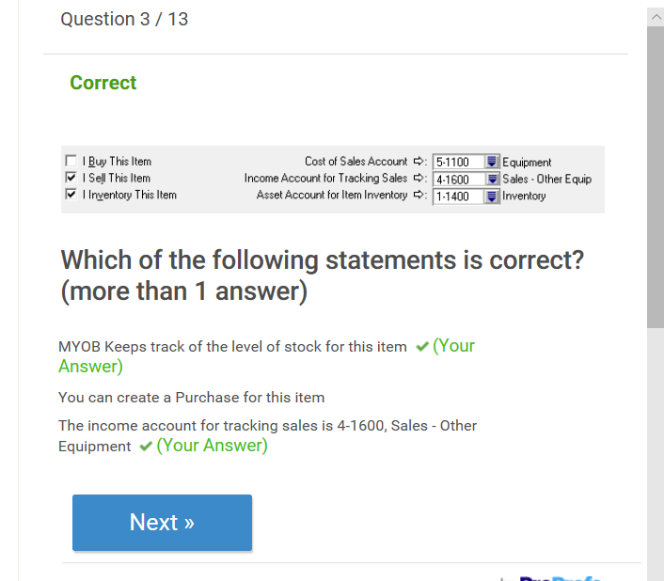
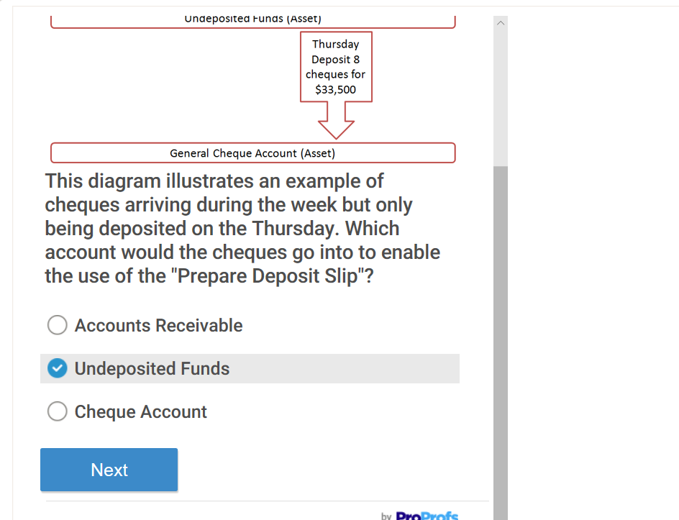
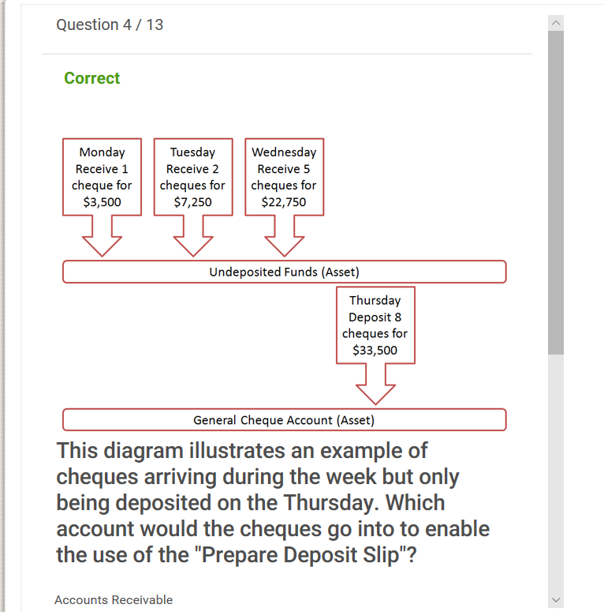
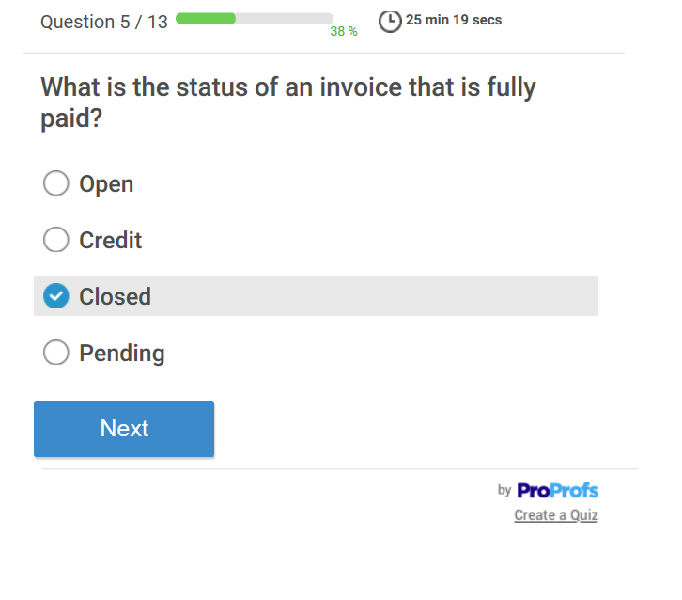
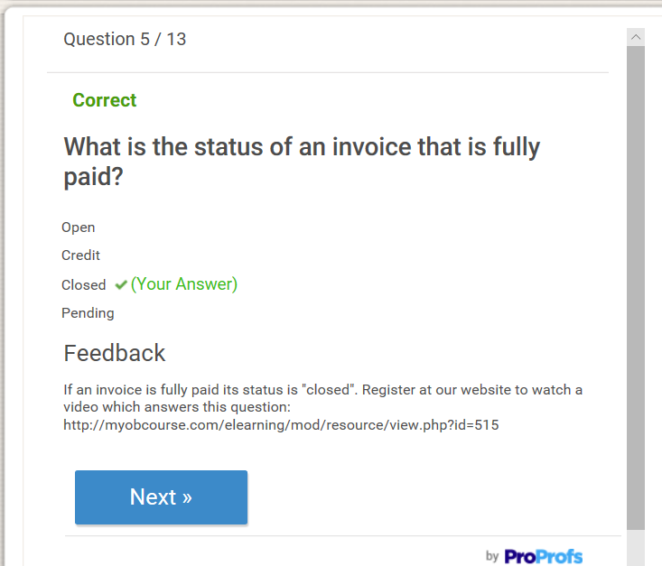
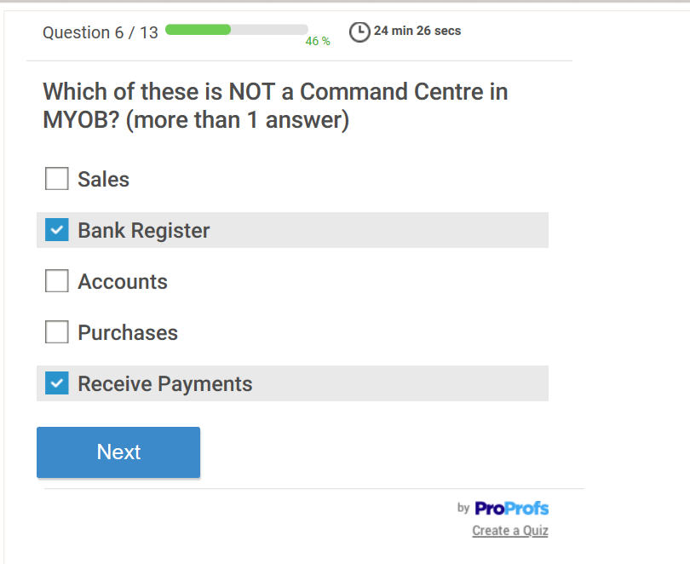
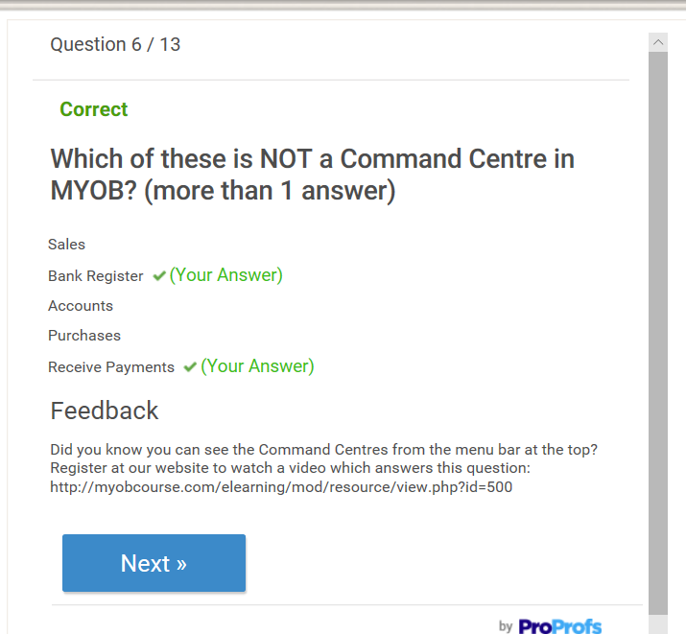
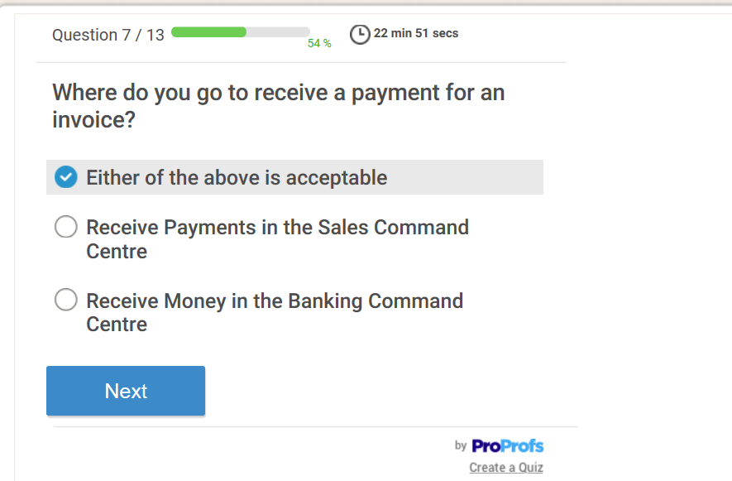
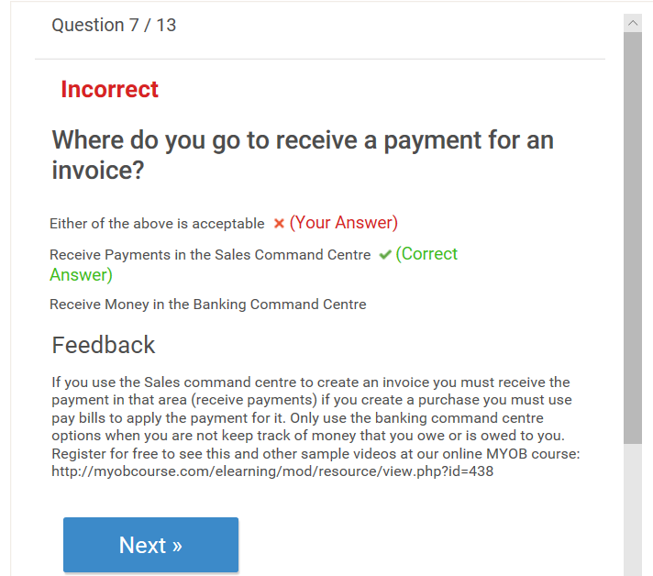
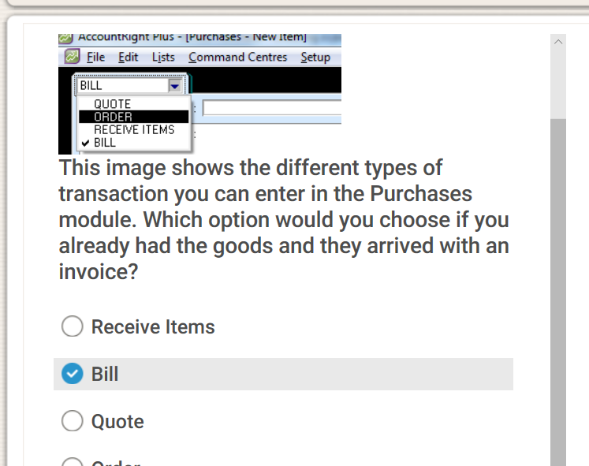
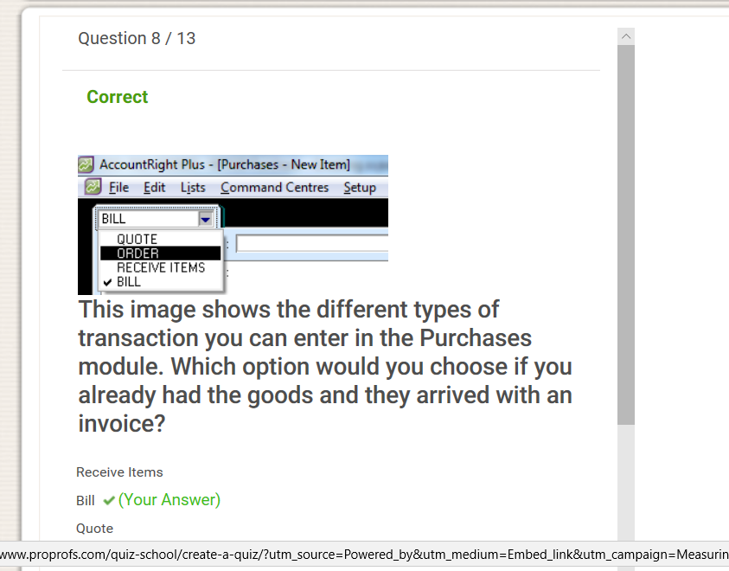
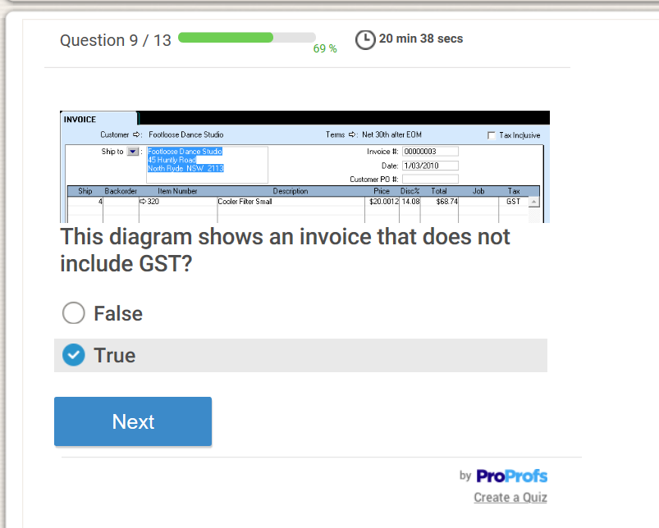
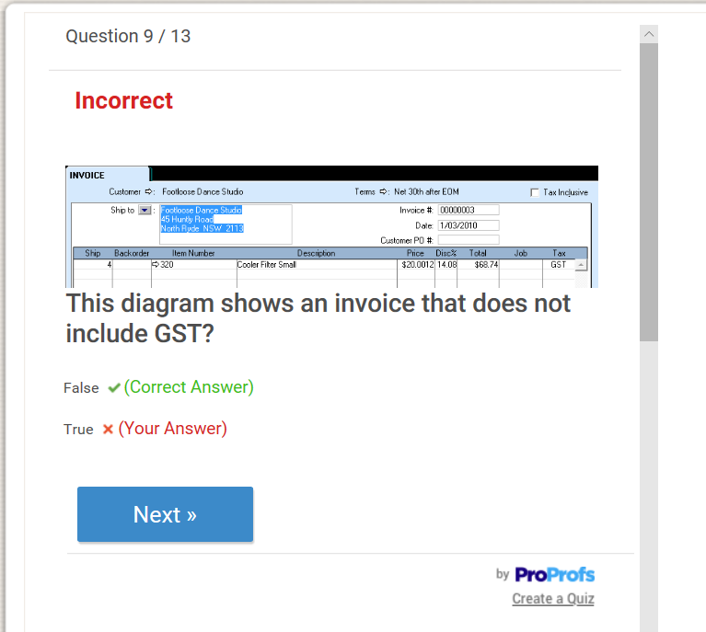
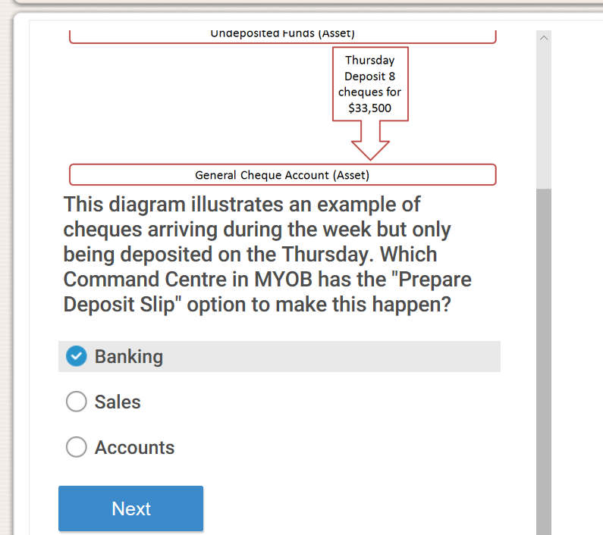
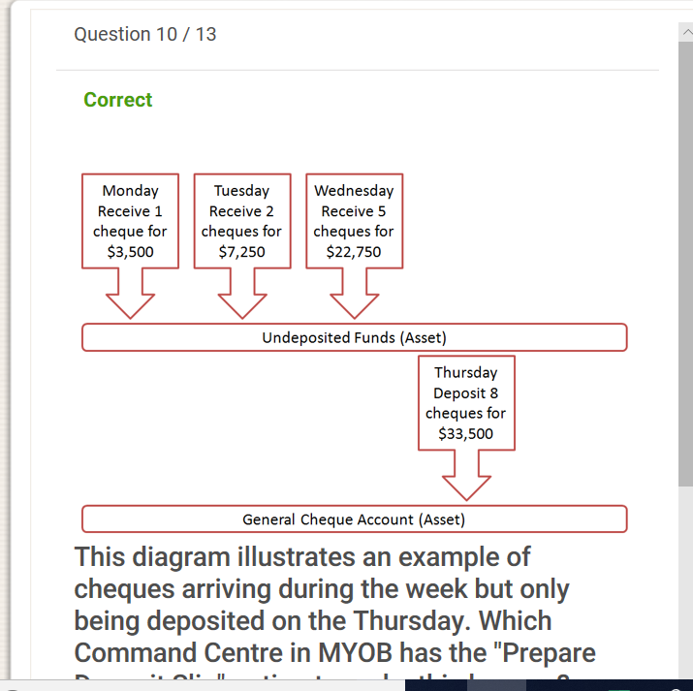
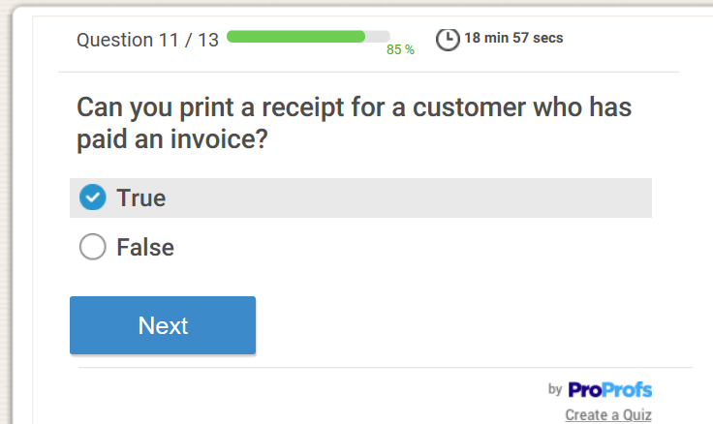
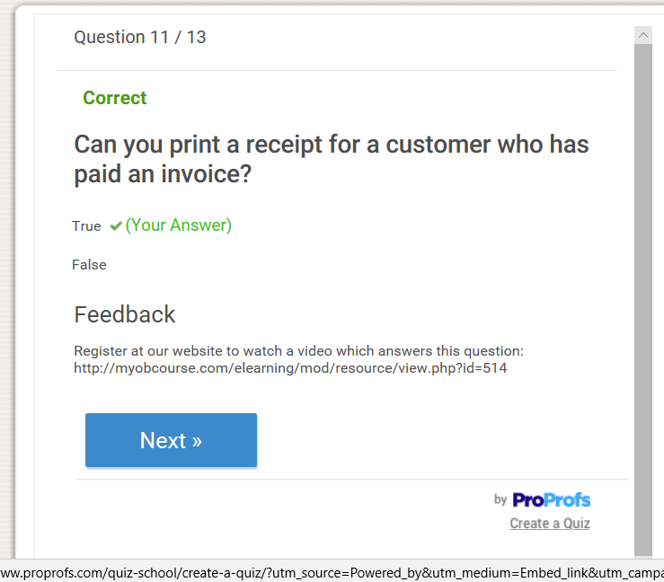
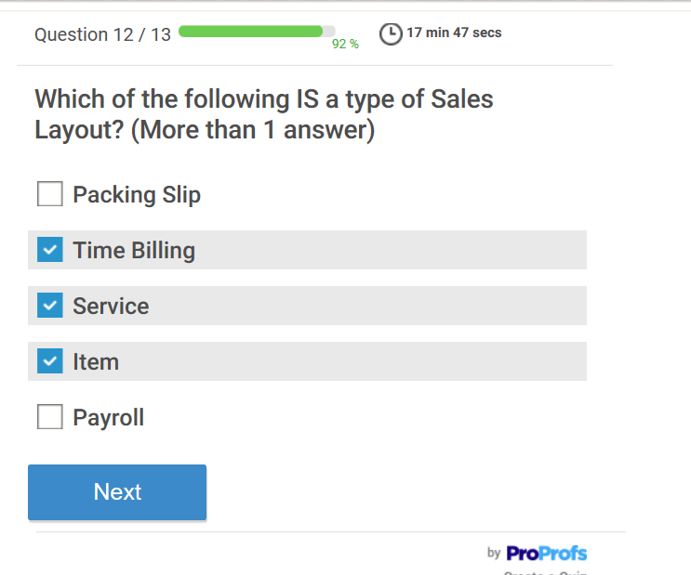
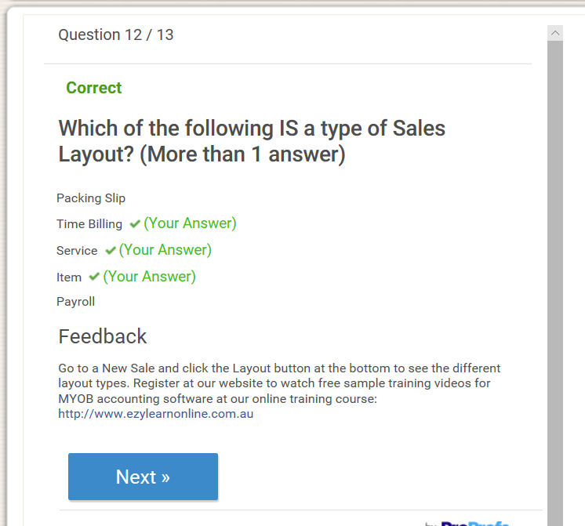
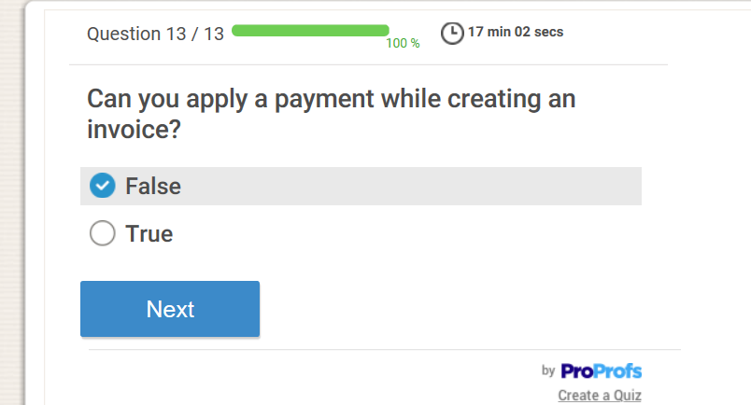
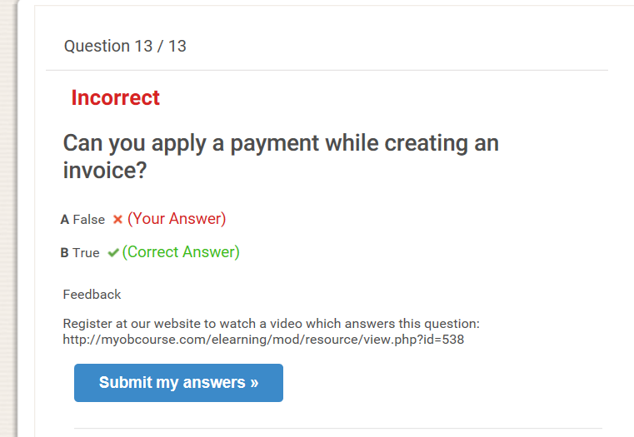
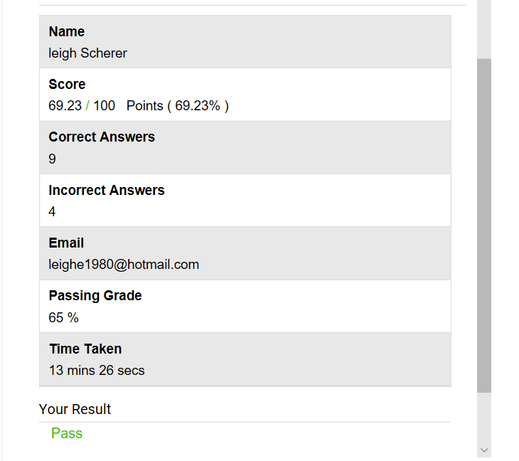
MYOB is a handy computer system for a small to medium sized business. It holds many functional activities and it was great to learn a different system that involved all business transactions from setting up a new company, inputting account balances, creating sales and purchases to creating reports at a particular point in time.

Assignment Step 9 – ACC11081
Business transactions – My company – Leigh’s Fresh Start.
My company is a wellness services and goods company which supplies healthy eating, spa massages and organic facial products. When I initially set up MYOB, I entered opening balances for each account. Below is what I started with opening balances:
Assets
Bank Account $16 000
Trade Debtors $3 000
Furniture at cost $2 000
Computers at cost $2 000
Total Assets $23 000
Liabilities
Visa Card $3 000
Business Loan $10 000
Total Liability $13 000
Equity
Owner Shareholder Capital $10 000

Accounting equation Assets – Liabilities = Equity
$23 000 - $13 000 = $10 000

During the set up phase I created the customers below

And also these suppliers

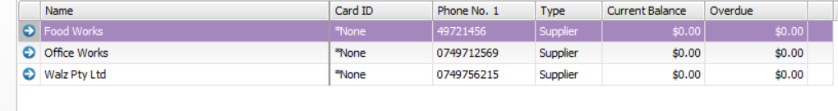

Transactions 1: Below is a sale from LJK Industry. They purchased a massage and night firming cream for $300.00
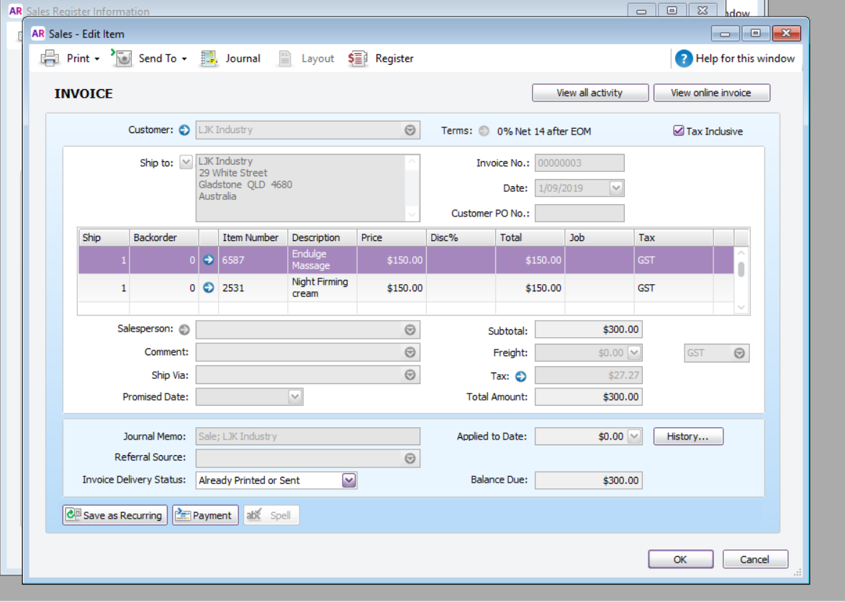

Transaction would be:
DR Trade Debtors (Trade Debtors is an asset. Increase to asset is a debit)
CR Sales Income (Sales Income is a revenue. Increase to revenue is a credit)
CR GST Collected (GST Collected is a liability. Increase to liability is a credit)
Transaction 2: ZZY Wholesale made a purchase from Leigh’s fresh start for the fresh food box. The amount was $200.00. I created the below quote for ZZY Wholesale.

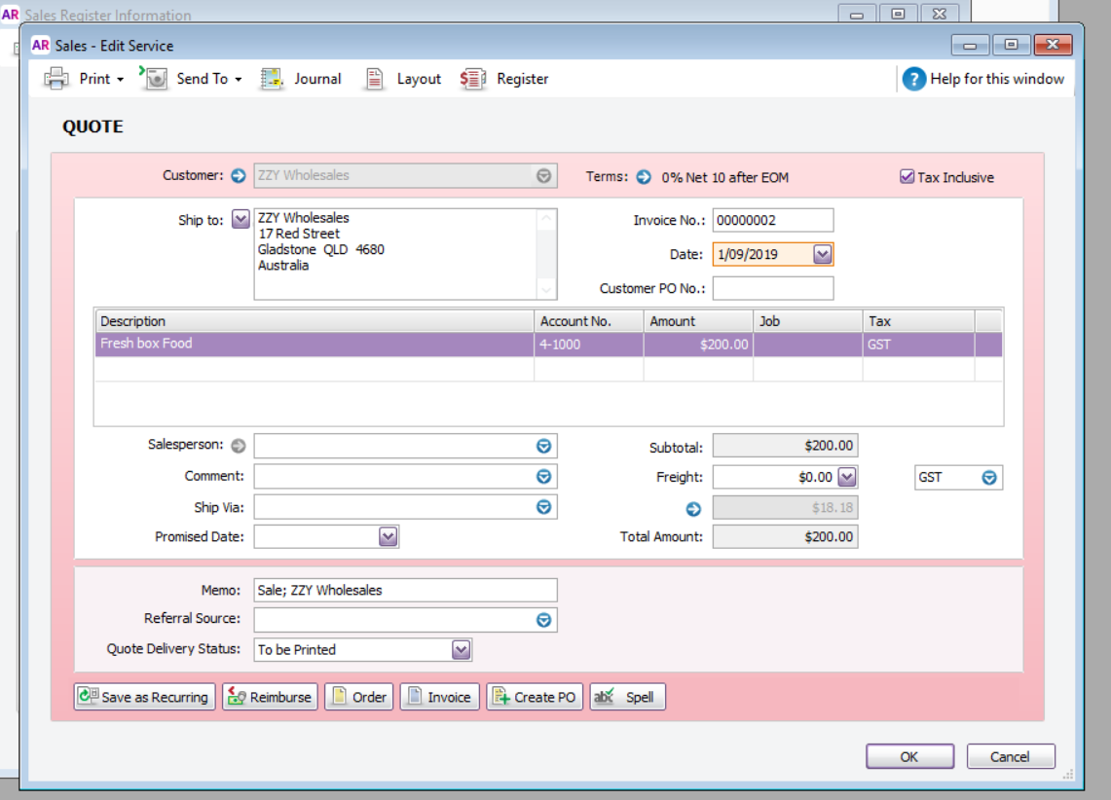
Once ZZY Wholesale decided to complete the purchase I changed the quote into the invoice below.
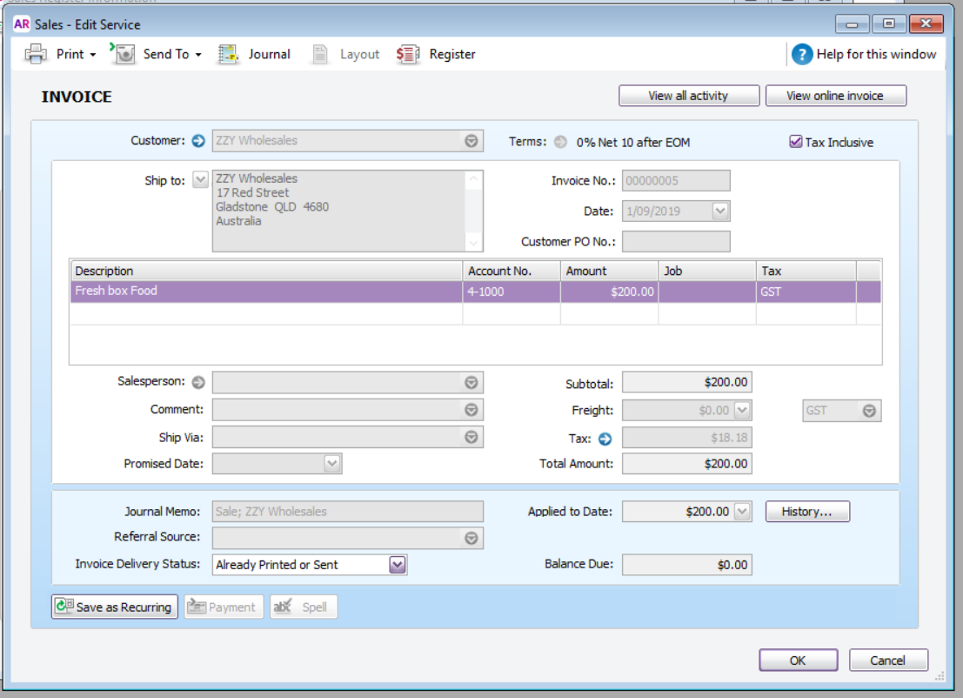
This transaction would be:
DR Trade Debtors (Trade Debtors is an asset. Increase to asset is a debit)
CR Sales Income (Sales Income is a revenue. Increase to revenue is a credit)
CR GST Collected (GST Collected is a liability. Increase to liability is a credit)

Transaction 3: LJK Industry decided they brought the incorrect cream and returned it for a refund.
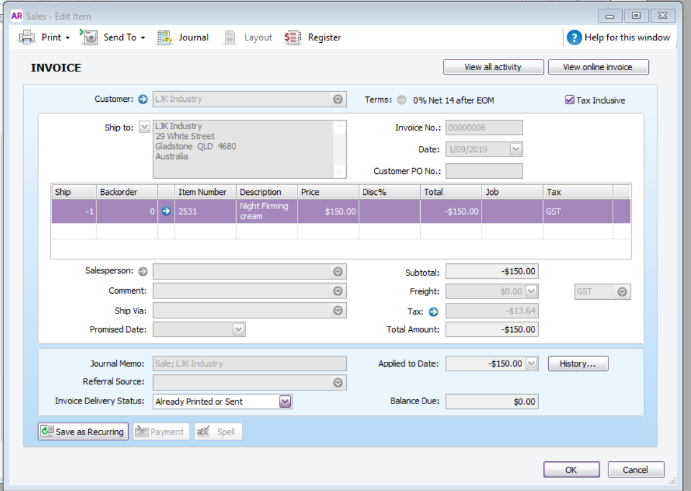

The transaction for this return would be
DR Sales Income (Sales Income is a revenue. Decease to revenue is a debit)
DR GST collected (GST Collected is a liability. Decrease to liability is a debit)
CR Trades Debtors (Trades Debtors is a asset. Decrease to an asset is a credit)

Transaction 4: ZZY Wholesale made another purchase
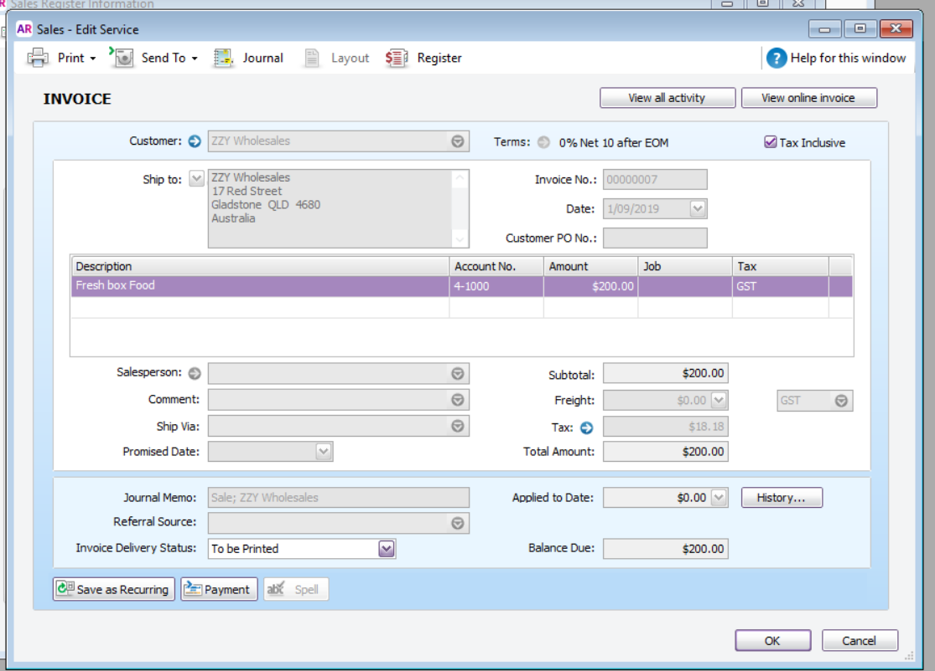
This transaction would be:
DR Trade Debtors (Trade Debtors is an asset. Increase to asset is a debit)
CR Sales Income (Sales Income is a revenue. Increase to revenue is a credit)
CR GST Collected (GST Collected is a liability. Increase to liability is a credit)
Transaction 5: Payment was received from the customer ZZY Wholesale
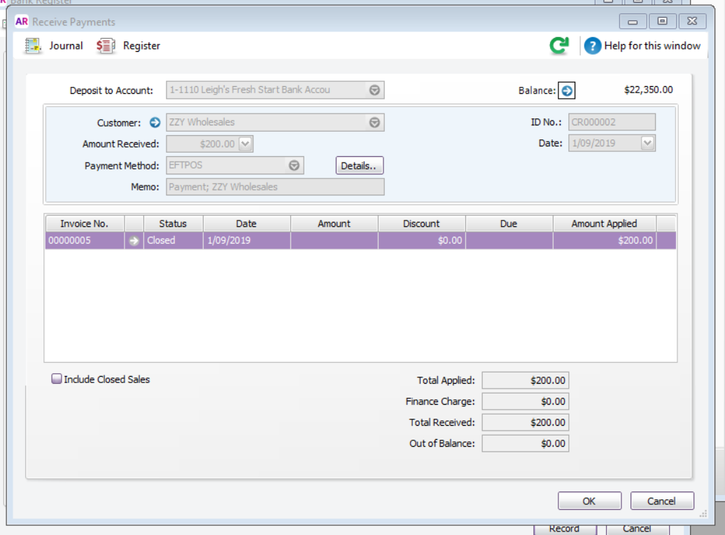
Transaction would be
DR Cash at bank (Cash at bank is an asset. Increase to an asset is a debit)
CR Trade Debtors (Customer LJK Industry) (Trade Debtors is an asset. Decrease to an asset is a credit)
Transaction 6: Payment was received from the customer LJK Industry for their invoice created.
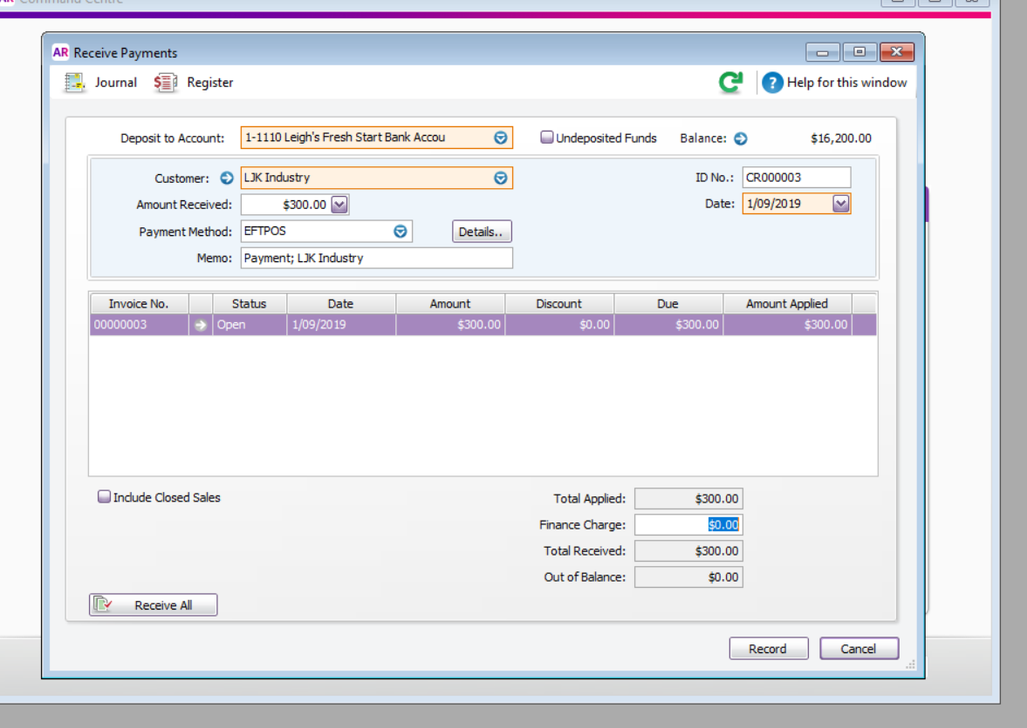
Transaction would be
DR Cash at bank (Cash at bank is an asset. Increase to an asset is a debit)
CR Trade Debtors (Customer LJK Industry) (Trade Debtors is an asset. Decrease to an asset is a credit)
Transaction 7: Leigh’s Fresh Start made the monthly rent payment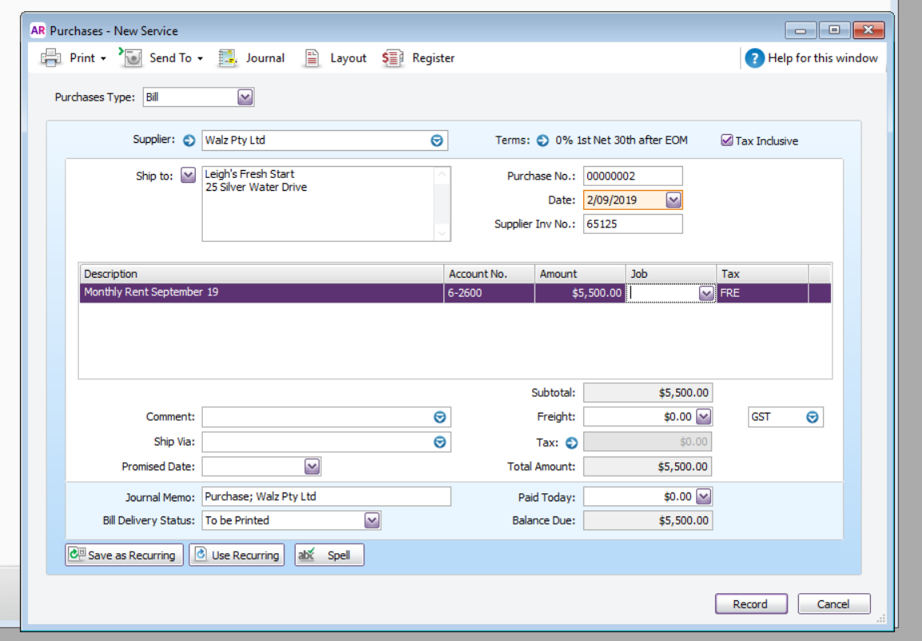
Transaction for this would be: NOTE: no GST included in this payment
DR Rent expense (Rent expense is an expense. Increse to an expense is a debit)
CR Trade Creditors (Trade Creditors is a liability. Increase to a liability is a credit)
Transaction 8: Office works – Stationery $180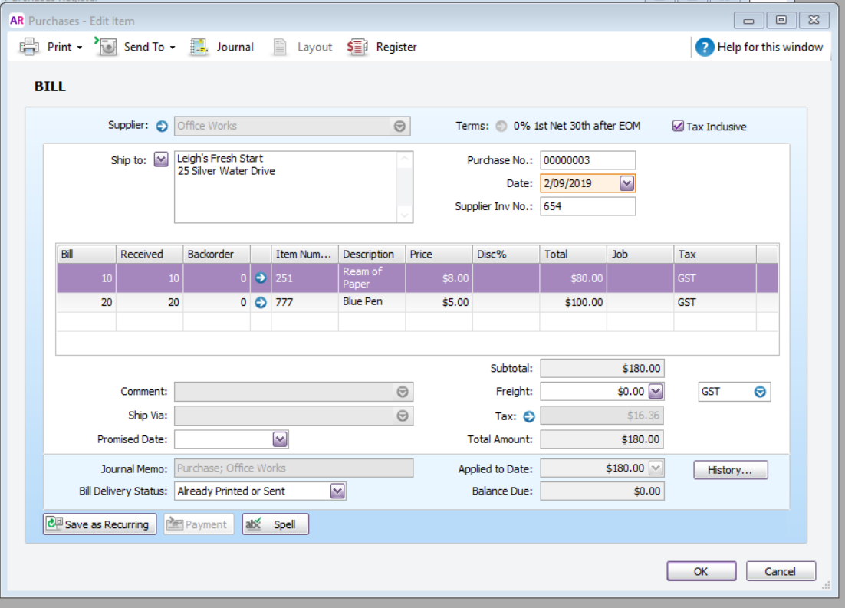
Transaction for this would be:
DR Stationery Expense (Stationery Expense is an expense. Increase to an expense is a debit)
DR GST Paid (GST Paid is a liability. Decrease to a liability is a debit)
CR Trade Creditors (Trade Creditors is a liability. Increase to a liability is a credit)
Transaction 9: Leigh’s Fresh Start paid the account from Office works with the company’s credit card
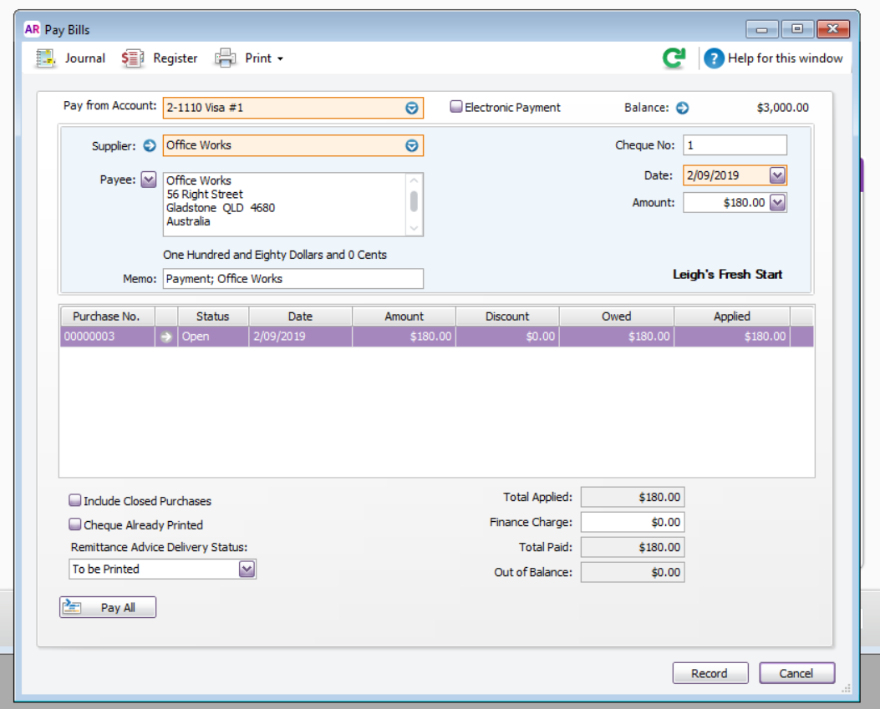
Transaction would be:
DR Trade Creditors (Trade Creditors is a liability. Decrease to a liaiblity is a debit)
CR VISA # 1 (Visa #1 is a Liability. Increase to a liability is a credit)

Transaction 10: Leigh’s Fresh Start paid the Walz Invoice
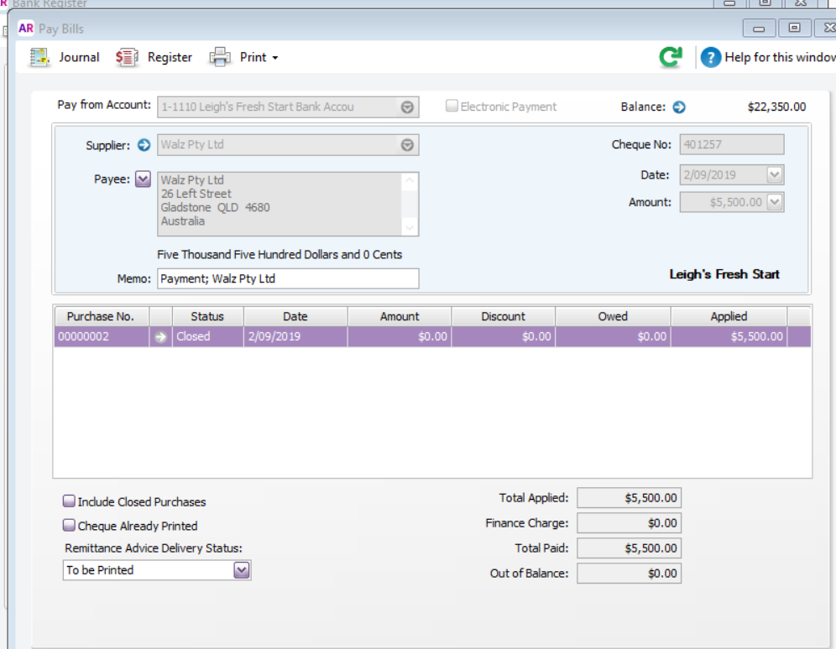
Transaction for this would be
DR Trade Creditors (Trade Creditors is a liability. Decrease to a liability is a debit)
CR Cash at bank (Cash at bank is an asset. Decrease to an asset is a credit)

Transaction 11: Payment given to customer LJK Industry for the credit
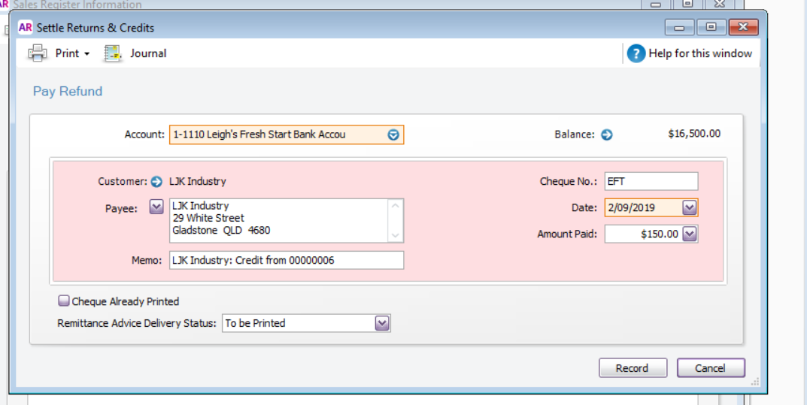
Transaction for this would be
DR Trade Debtors (Trade Debtors is an asset. Increase to an asset is a debit)
CR Bank account (Bank account is an asset. Decrease to an asset is a credit)

Transaction 12:
Another sale to ZZY Wholesale

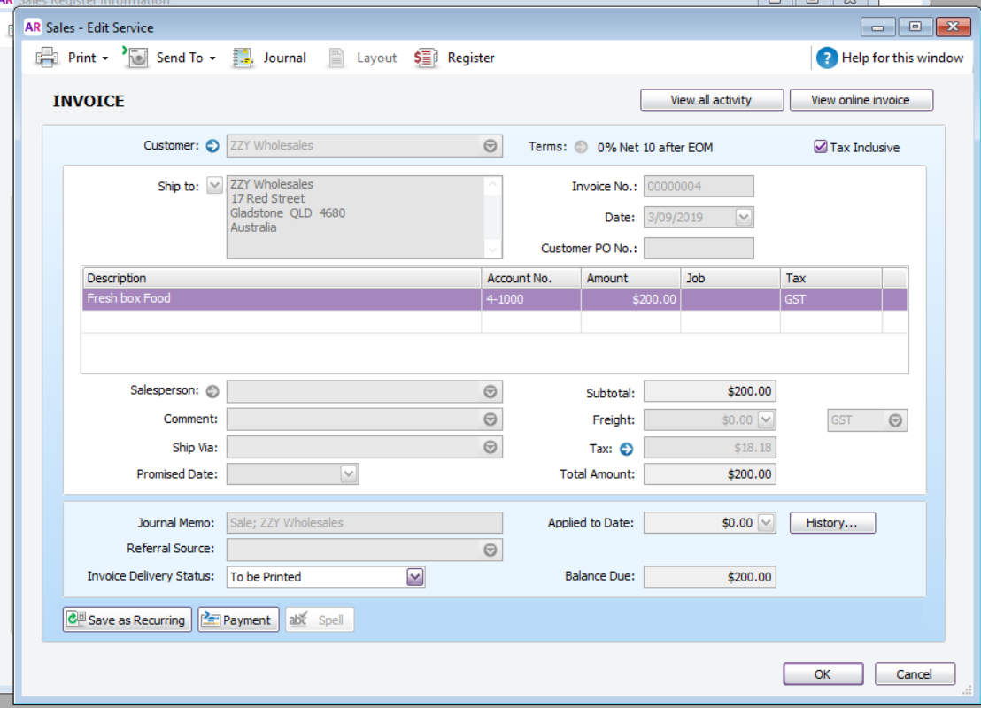
This transaction would be:
DR Trade Debtors (Trade Debtors is an asset. Increase to asset is a debit)
CR Sales Income (Sales Income is a revenue. Increase to revenue is a credit)
CR GST Collected (GST Collected is a liability. Increase to liability is a credit)

Transaction 13: Leigh’s fresh start made cash sales $1500.00
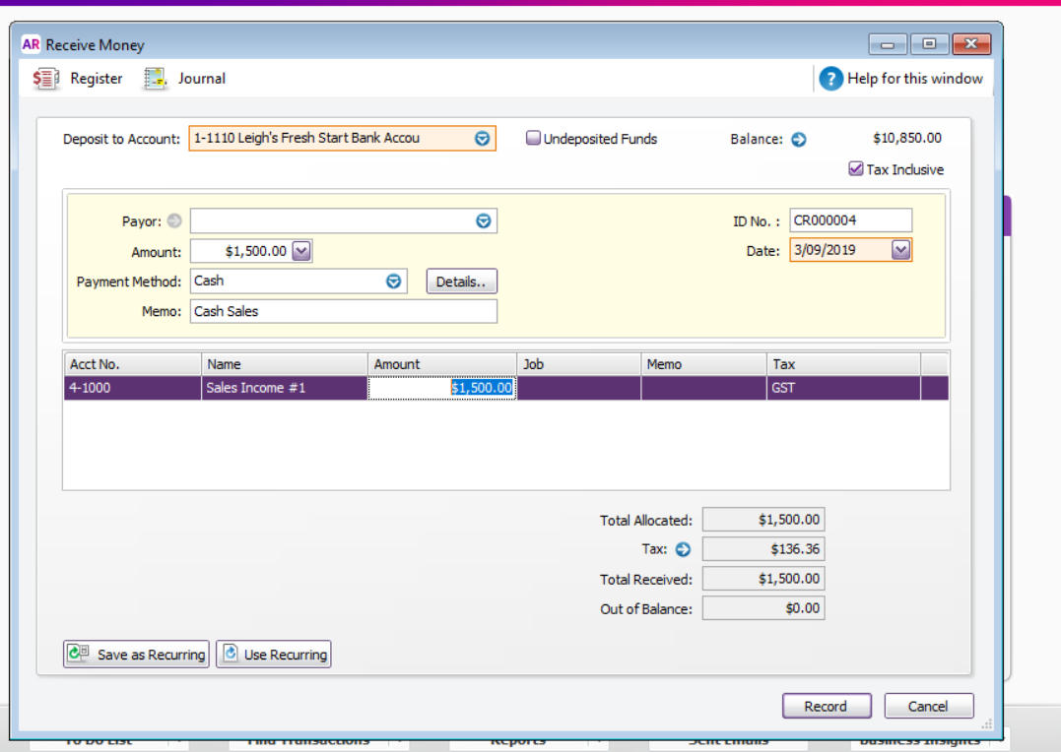
Transaction would be:
DR Cash at bank (Cash at bank is an asset. Increase to an asset is a debit)
CR Sales Revenue (Sales revenue is a revenue. Increase to a revenue is a credit)
CR GST Collected (GST Collected is a liability. Increase to liability is a credit)

Transaction 14: Leigh’s fresh start had a capital injection from the Owners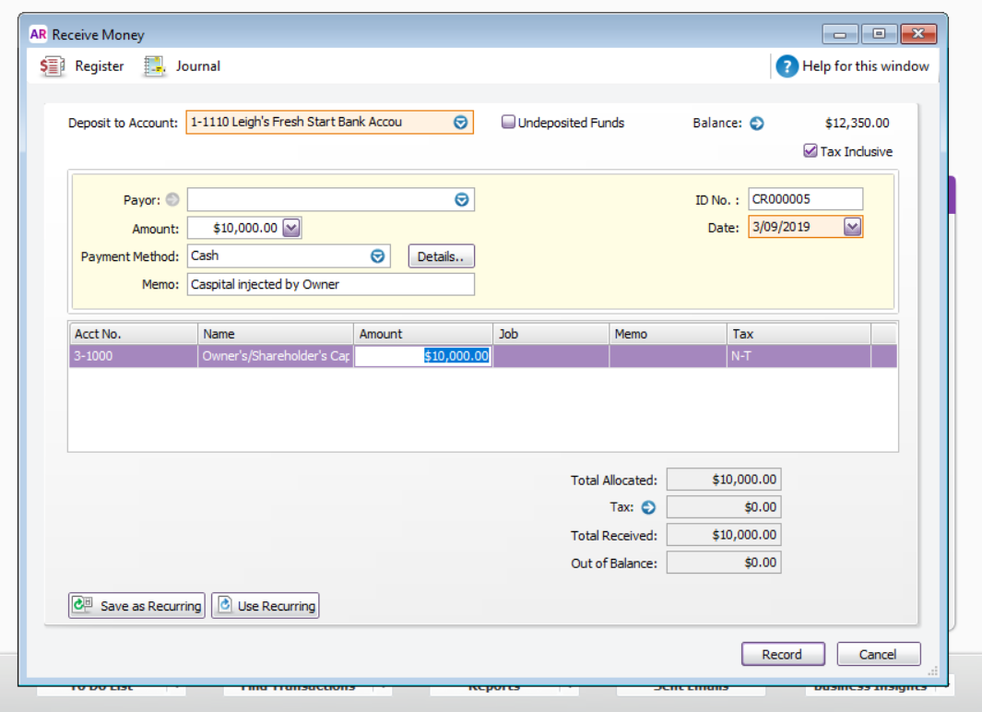
Transaction would be
DR Cash at bank (Cash at bank is an asset. Increase in an asset is a debit)
CR Owners Capital/Equity (Owners Capital is an equity. Increase is equity is a credit)

Journal Listing
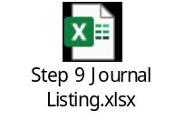
I think I may also have gone a little overboard on the transactions. As I drafted the above transactions I utlised my learnings from this semester and last semester and compiled the journal transactions before printing out the journal transactions from MYOB. I was quite surprised that I have an 80% in getting these journals correct. I had one incorrect with the GST not being applied.
Profit and Loss
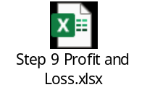
I double checked this figure for Income against the transactions journal listing and the amounts matched. I think I may have over estimated the rent and probably could of applied an accural to spread this out as the profit and loss only covered a three day period, whereas the rent is a payment for the month. Leigh’s fresh start would need to make a lot of sales to cover just the monthly rent.
Balance Sheet
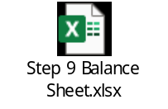

I wanted to cross check the figures on the balance sheet with the journal entries to double check they all match. Accounting Equation
Assets $29750.00 - Liabilites $13368.17 = Equity $16381.83
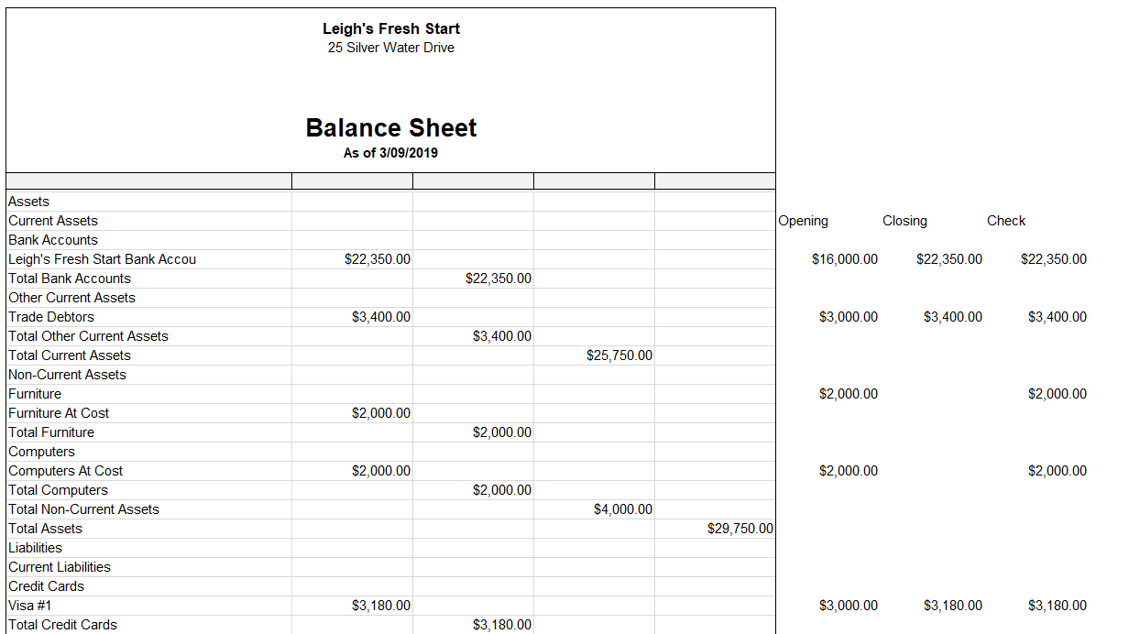
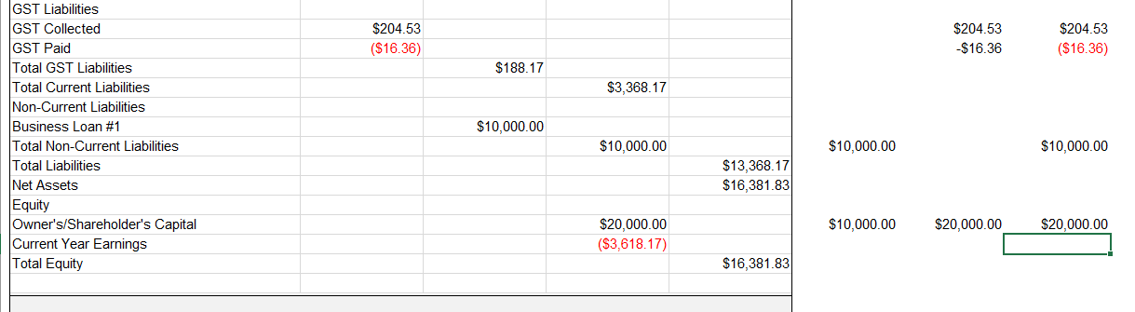
Cashflow
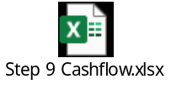
I really enjoyed completing this assignment. My biggest concern was not knowing which accounts belonged where in the chart of accounts. However as the weeks progressed, we had more exposure to the chart of accounts and I feel a lot more comfortable knowing which accounts sit either in the assets, liabilities and equity. Seeing the duality to each transaction has reinforced the three things we need to learn.
Increase to Assets and Expenses are Debits and belong on the LH side
Increase to Liabilities, Revenue and equity are credits and belong on the RH side.
Also seeing how the transactions flow to the specific chart of accounts and then onto the balance sheet has helped formed a picture of the overall business reality of my compnay. Even though I set the opening balances I was able to follow through from the balances of each account to the ending balances on the balance sheet. The capital injection of $10 000 boosted the equity in the company to offset the loss made for the three day period. Without this injection of capital of equity of the business would be lower than the opening balance.
There are a few ratios we could apply to anaylses this data
Debt/Equity ratio = $10000/$16381.83 = 61% - This equats to 61% of the equity being funded by loans
Liquidity Ratios = Current assets/current liabilities = $25750/$3368 = 764% - A good return on the current assets if needed to be liquated quickly.
Equity Ratio = Equity/total assets = $16 381.83/$29 750 = 55% funded by owners
Debt Ratio = Total Liability/total assets = $13 368/$29 750 = 45% funded by debt
The business reality for Leigh’s Fresh Start is showing an upward trend for the three days of trading however to offset the expenses incurred for the start of the month, Leigh’s Fresh Start would need to make approx. six to seven thousand dollars in sales to return a ten percent profit margin.

Assignment Step 10 – ACC11081
Depreciation
When I first started thinking about depreciation and how I would start this assignment I thought I had a perfect work scenario that I could write about. As we went through the lectures, I started to think that my work scenario wasn’t a depreciation example. In 2015 the company I worked for won a contract on Curtis island and part of the mobilization of this project was to purchase some plant and equipment. This plant and equipment include cranes, forklift, trucks and EWPs. The company purchased this equipment outright instead of leasing them. A business case and RFA was raised, approved and they were purchased. These items would represent plant and equipment. Each month I had to do a journal that would credit the asset and debit the expense account. The journal represented taking a portion of cost of the asset and transferring this cost to the expense. As this equipment was used to generate revenue a portion of cost was transferred via this journal to offset the revenue component. This is what they call the matching principle. This amount was a predetermined amount each month which was based on the below:
Purchase price – residual value + overhead costs + maintenance costs + freight/useful life in years.
This yearly amount was then divided in monthly amount then divided into working days per month which created the amount that was journaled every month
Some months were higher due to smaller working days per month.
Now where I started to get confused was the recovery on this plant and equipment. This company has a predefined sell rate each month for the pieces of equipment so the profit margin changed each month on this equipment.
This led me to think was this an example of depreciation or capitalization of equipment. I turned to google for my answer. Below is the google representation of capitalization:
“Capitalization, in accounting, is when the costs to acquire an asset are expensed over the life of that asset rather than in the period it was incurred”
The google representation of depreciation is:
“Depreciation is an accounting method of allocating the cost of a tangible asset over its useful life and is used to account for declines in value”
After reading through these definitions I think my work example more represents the definition of capitalization and not depreciation.
So, what is depreciation and how does my company Grammer depreciate their assets?
I briefly ran through the definition above, but my understanding of depreciation is:
Transferring the value used of an asset each period as an expense as it generates revenue or economic benefits for the company. This value is the wear and tear of the asset which is consumed to generate the economic benefits.
When assets are first purchased, they are recorded at cost on the balance sheet. This cost includes purchase price, taxes less discounts, freight and starting costs. Businesses use either three methods to depreciate this value over the useful life period.
Method 1 – Straight line depreciation. This is the same amount each period and the formula to calculate this is:
Depreciation amount/useful life (Depreciation amount is the cost – residual amount)
Method 2 – Diminishing value. This value is derived from a percentage being applied to the depreciation amount each year. This amount then reduces each year.
Method 3 – Units. The formula for this amount is calculated below
Depreciation amount/operating hours = cost per hour
The hours used x cost per hour determines the depreciation amount.
Let’s have a look at Grammer’s balance sheet and see if we can determine which depreciation method they use.
Below is a snip it of Grammer’s balance sheet for 2018 and 2017 for their non-current assets. I learnt in Maria’s video that company’s list in order of liquidity. You can see below that Grammer’s largest non-current asset is property, plant and equipment. I also learnt that land is not depreciated. Below also shows an almost 50% increase in non-current assets between 2017 and 2018. This was due to the acquisition of TMD group.
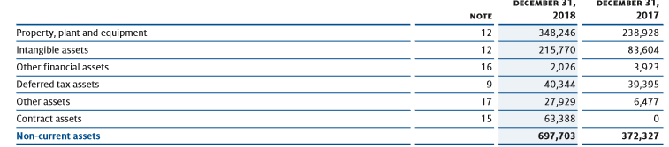
The entry is only shown as one-line item and does not include the depreciation amounts. Reading further into the 2018 annual report the property, plant and equipment is broken up into the below
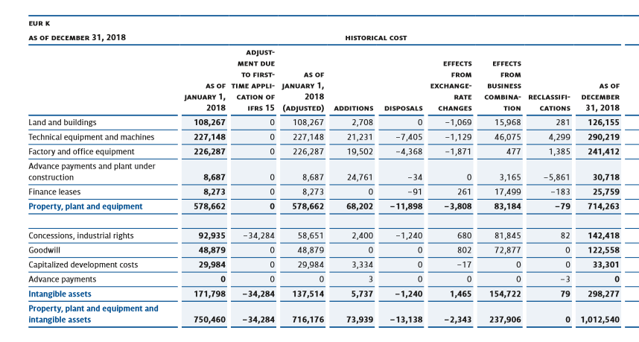
This data shows the historical costs of the property, plant and equipment. These costs include the additions, disposals, exchange rate changes and reclassifications. You can see the total value of EUROS 714,263 does not match the total on the balance sheet which was EUROS 348,246. This tells me that the property, plant and equipment has been depreciated and a portion of cost has been transferred as an expense on the income statement.
Let’s take the factory and office equipment. It has an historical cost of 241,412. Let’s say the journal each month to transfer the depreciation amount would be
DR Depreciation expense (increase in an expense would be a debit)
CR Accumulated depreciation (decrease in asset would be credit)
However, the asset account itself isn’t reduced. A contra asset account for each property, plant equipment holds the credit journal to represent the total deprecated amount.
Balance Sheet
Factory and office equipment 241,412
Accumulated depreciation (factory and office equipment) (177,466)
I have included below which represents the non-current property, plant and equipment values as seen on the balance sheet. The value showing for factory and office equipment is 63,946 which means 177,466 has been depreciated over the useful life to date.

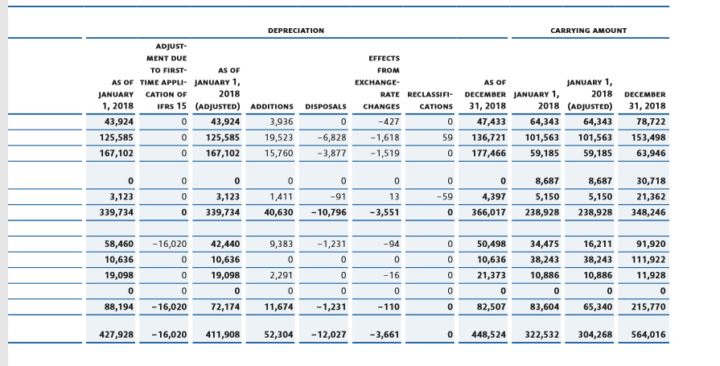
So which method does Grammer use to depreciate their non-current assets? Reading through the below snip-it tells me that Grammer uses method 1, straight line method over the useful life.
If the Factory and office equipment has a historical cost of 241,412 (assumed a residual value of 5,000) and a useful life of 10 years. Deprecation amount would be:
241.412 – 5,000/10 = 23641.20 per year.
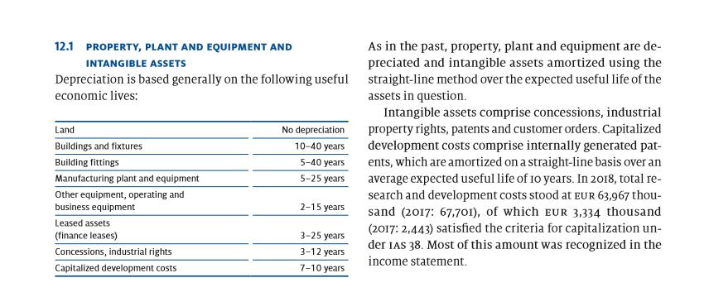

Below is one more example of depreciation transfer
Technical equipment and machines:
DR Depreciation expense 18 681.26
CR Accumulated depreciation (Technical equipment and machines) 18 681.26
Technical equipment has a historical cost of 290,219, residual value of 10,000 and useful life as 15 years. Deprecation amount would be 290,219 – 10,000/15 years = 18,681.26 per year
2016/2015 Annual report
During the 2016/2015 period the below was depreciated.

Compared to the 2017/2018 non-current assets the 2015/2016 shows a steady figure.

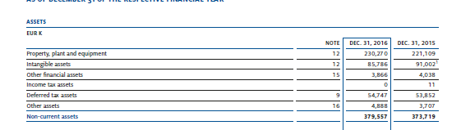
The historical costs of each item are shown below
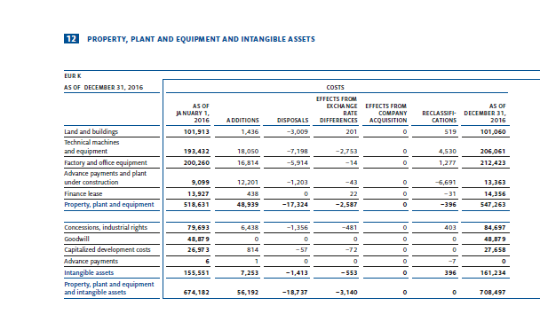
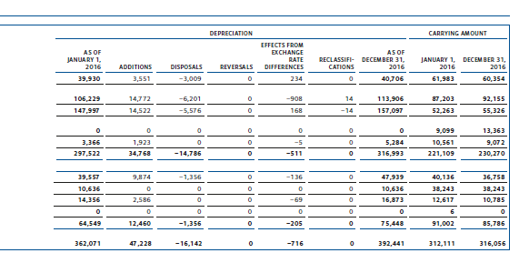

Companies have the option of revaluating non-current assets throughout their useful life. The treatment of such differs from an increase in cost to the asset as opposed to a decrease in cost to the asset. If the asset is re-valued and the asset is recorded at a higher increase in cost the transaction would to record the surplus value in the equity section on the balance sheet under Asset revaluation reserve. If the revaluation resulted in a decrease to the asset the difference would be transferred to the income statement as an expense and reduced from the profits and moved to retained earnings.
The transaction to record a decrease in the value of factory and office equipment would be:
DR Expense (Increase in expense is a debit)
CR Factory and office equipment (Decrease in an asset is a credit)
If property, plant and equipment is re-valued the accounting standard states that all items similar in nature need to be re-valued and not just a single item. This prevents the company from choosing items that may potentially help increase their equity base.
As in inventories, where Grammer applied the weighted average method to account for inventories, I am also surprised that Grammer would apply the straight line depreciation. With the vast differences in their product lines and varying degrees of sales, taking a straight line approach could either over state their profit and losses in any given month. The deprecaition should be in line with the rise and fall of sales as components are manufactured ready for the market. Maybe the diminishing value would be a better approach as cars, trucks, planes and truck components create more wealth at the start of their lifespan.

