Assignment 2 Step 4
Economic and business drivers for Jumbo Interactive Ltd
Change is a big part of a business’s reality. A firm forecast can change every day with unknown changes to the economy, markets, suppliers, customers and general community. However, for a business to succeed they need to have economic business drivers adding value to their business despite the unknown. I have concluded from reading through the annual reports that you can’t rely on these for face value. From Jumbo Interactive Ltd.’s perspective their annual reports tell a very successful story and If I was looking for an investment, and I didn’t have the knowledge I now have with analyzing financial statements, Jumbo Interactive would have been one company I would have considered. While reading through their annual reports I was able to link some economic business drivers to key accounting drivers which have shown growth over the last two years. Being an on-line company and selling on-line lottery services a company needs to stay ahead with advancement of technology and improving the accessibility and functionality of this software. This is one of the economic business drivers for Jumbo Interactive Ltd as it has contributed to a massive growth in sales during the 2019. It was during this year that speech recognition advancements were made for customers to streamline their lottery purchases. 2019 also say a 106% growth in increase of customers.

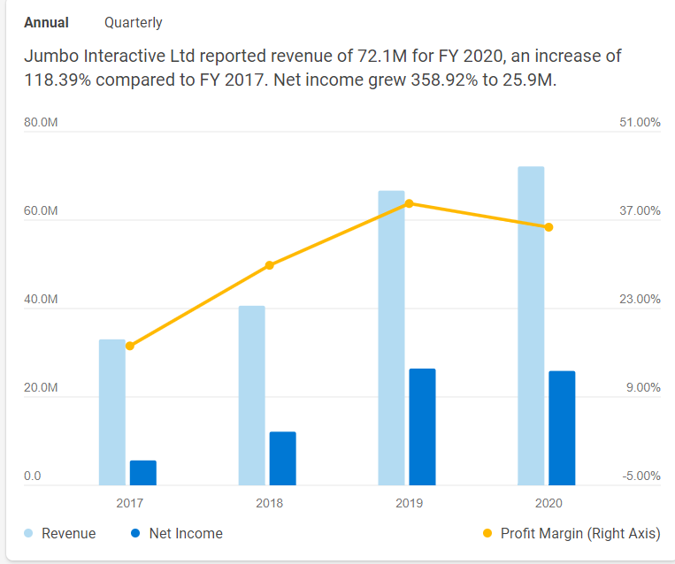
Another advancement in technology was implementing the Lotto Party. Jumbo Interactive Ltd’s customers can now organise and create groups syndicates through a special app. Another business driver that has increase the profits of Jumbo Interactive Ltd.

Another economic and business driver for Jumbo Interactive Ltd is leveraging off the success of major jackpot wins. Evidence has proven that sales rocket in the 24 hours leading up to a major jackpot. Compacting this with technology advancements with ease of lottery purchases and marketing ploys of winning big sums of money has certainly played a part in huge growth for Jumbo Interactive Ltd in the form of sales and profit margins. The annual report mentions that during these big jackpots wins that 1 in 3 Australians purchase a lotto ticket. From the information below you can see that number of online accounts from increased from 161698 to 444004 in two years and customers have doubled. All within the year of 2019 with a increase of jackpots to 49.
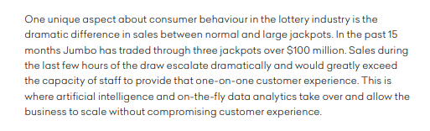
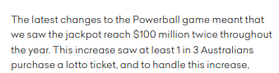
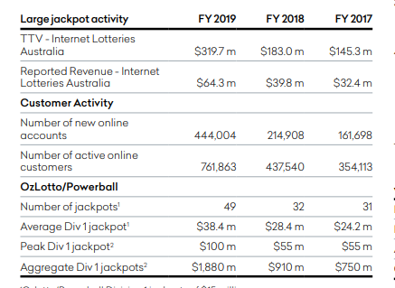

The below graph depicts the percentage age bracket of customers that purchase tickets through Jumbo Interactive Ltd. The highest ticket purchasers are between the ages of 35 and 50. This would be an economic and business driver for Jumbo Interactive Ltd.
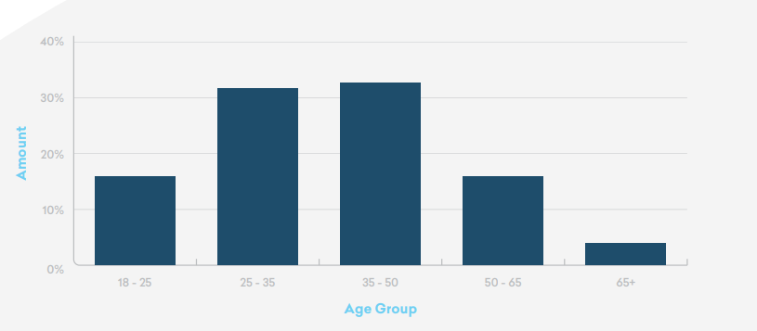
If we look at the statistics from the website below, we can see the number of people in Australia who are between the ages of 35 and 50. The highest population of people in Australia are between these ages. Targeting these age brackets with simplified and easy to use ways to purchase lottery tickets is showing immense increases in profits for Jumbo Interactive Ltd. There is ongoing trend that the older generation are starting to use the on-line services with the help of the younger family members.
Five-year age groups | Australia | Community profile (id.com.au)
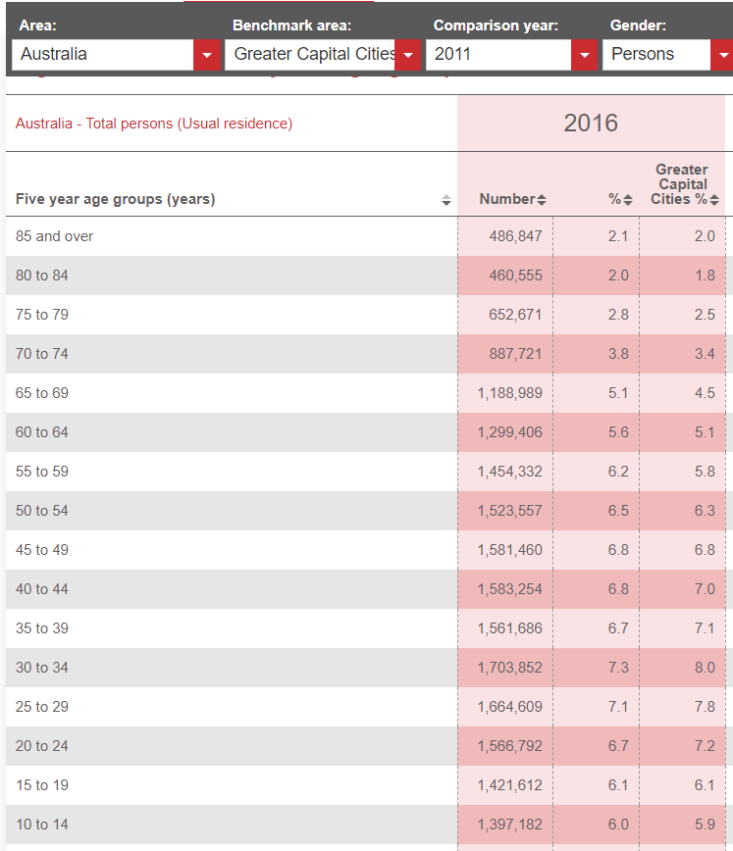
Selling on-line lottery software to charity’s would be another economic and business driver for Jumbo Interactive Ltd. What better way to support a charity of your choice by buying a ticket in millions of dollars’ worth of property or cash and all for a good cause. Over the last two years Jumbo Interactive have signed up some major Australian charities to use their software for their lottery purchases. These new partnerships have increased Jumbo Interactive Ltd’s sales growth and reputation and being the biggest lottery software supplier in Australia.

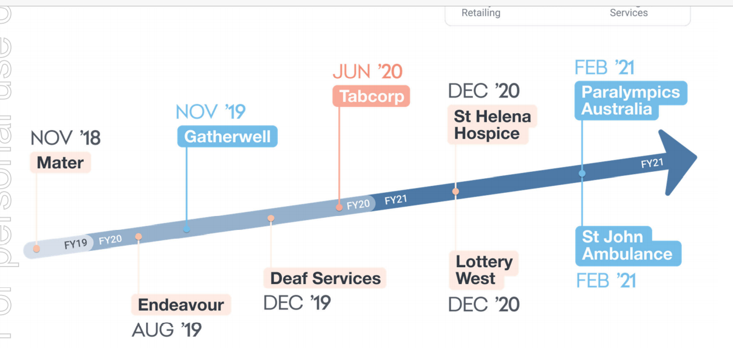

During the previous step in the assignment, I had a look at market monopoly and how Jumbo Interactive stacked up on other on-line lottery software companies. The website below gave me a fantastic insight into how Jumbo Interactive Ltd compares to 4 other companies. It really was quite interesting reading through the comparisons. Out of the four other companies Jumbo Interactive was the highest performer which tells me Jumbo Interactive Ltd has the market monopoly.
JIN - Jumbo Interactive Stock Competitors | MarketBeat
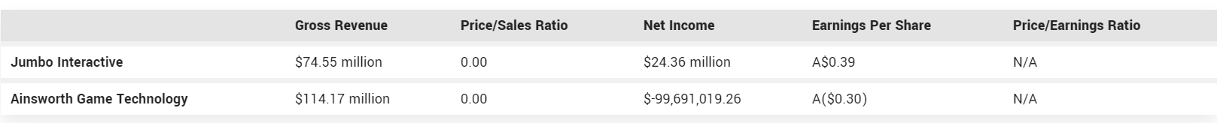
Also, on the topic of market monopoly we look at the expansion of the market to overseas. Jumbo Interactive Ltd acquired Gatherwell in 2019 and this really was the turning point for them. This acquisition turned their net operating assets from negative into positive and saw a positive growth in their key accounting drivers of Return of net operating assets, profit margin, growth in sales, asset turnover and an improvement in economic profit.
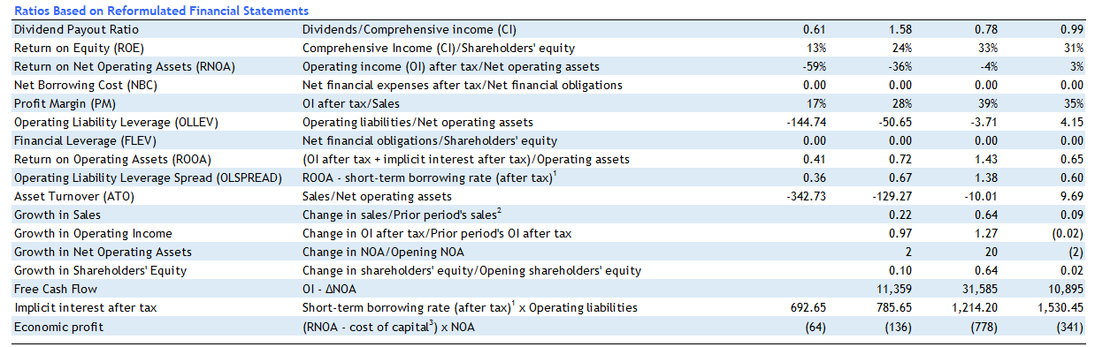
For summary I have listed below my thoughts on Jumbo Interactive Ltd.’s economic and business drivers
- Innovation through on-line software and technology
- Leveraging of Jackpot wins
- Age demographics in Australia
- Charity Lottery
- Market Monopoly
- Overseas acquisition
I really do hope that my view and thoughts on Jumbo Interactive Ltd’s economic and business drivers are somewhat accurate. It certainly made sense to me when I was linking them to the changes in the key accounting drivers. I feel I have a firm grasp on how my company is performing and I do feel they have had a successful last few year with acquisitions, technology advancements and growth in customer bases with signing of extended periods contracts. Despite the huge growth and turnaround in their economic performance I think there will be a smoothing out of their performance over the next few years with the biggest spike behind them and a slow and steady growth moving forward. (hopefully). The next challenge is the 5 year lookahead.

